



Contents

Login 4

Forgot Password 4

Reset password 4

Change password 5

Home 5

Master Data 6

Region Data 6

Country 6

State 7

District 8

City 9

Subscriber Master Data 10

Subscriber Type 11

Journal Master Data 12

Journal 12

Journal Group 13

Annual Journal Information 16

Journal Details 16

Volume Information 17

Annual Subscription Rate 18

Print Order 19

Agent Information 20

Add agent 20

Search agent 21

Inwards 22

Create Inward 23

View/ Edit Inward 26

Send Return 27

Pending Inwards 28

Update Receipt Number: 29

Subscriber 31

Edit Subscriber 31

View Subscriber Details 32

View subscription 33

Edit subscription 34

Please Refer List 35

Mailing\ Back Issue List 36

Mailing List 37

Generate and Print Mailing List 37

Display and Print Mailing List 40

Back Issue List 44

Generate and Print Back Issue List 44

Display and Print Back Issue List 45

Reminders 47

Send Reminders 47

Display and Resend Reminders 50

Process Flow 53

New Subscription 53

Create Subscriber 53

Renew Subscription 53

Create subscription 53

Address Change 54

Request for Invoice 54

Payment 60

Missing Issue 62

Reports 66

Master Data 66

List of Journals 66

List of Subscriber Types 69

List of agent 69

Rates for Journals 70

Print Order 70

Subscriber/ Subscription 71

List of Subscribers 71

List of invoice 72

List of back issue sent 73

List of renewal reminder sent 73

List of mailing list sent 74

Other Reports 75

Statement of Label 75

Circulation Figures for Journals 75

Subscription Figures 76

Inwards 76

Outstanding Bill 77

Mailing List 77

Bulk email Sender 78

Template 79

Help 79

Journal Distribution system

# Login

* To enter the Circulation department software [eVitaran], provide the respective username and password in the respective fields.
* The user name should be an email of the user.
* After entering username password, press ‘Button’ - ‘*Login*’ to login the system.
* On correct entry of username and password user will be navigated to home page.
* Reset button is used to reset the username and password field to blank values.

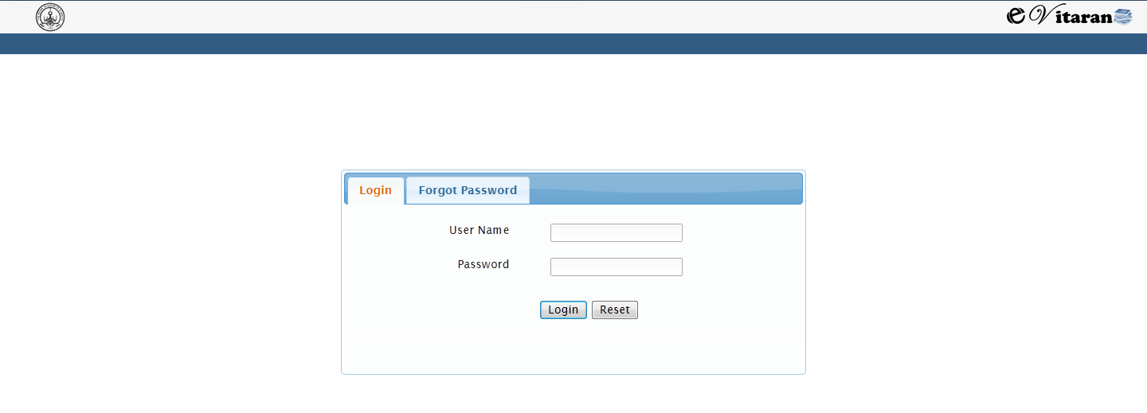

# Forgot Password

If the use forgets the password, the user can use the ‘Forgot Password’ option to reset the password and then using change password option setting it to the desired one.

## Reset password

* 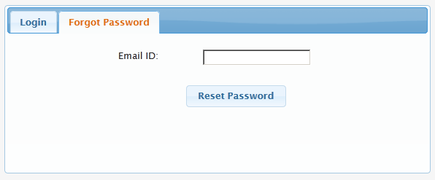Enter your email id and click on reset password.
* This will send the system generated password to the users mailed.
* Use this password to login the system for the next time.
* After entering the system generated password, you will be navigated to change password screen.

## C:\Users\I038668\Desktop\changePassword.JPGChange password

* Enter the new password twice. As new password and reenter the password.
* Press Button Login.
* This will store the newly entered password and you will be navigated to the home page.

# Home

* Home page is the mail window of the eVitaran system.
* From this page user can navigate to different process option
* The process options are:
  + Inward
  + Subscriber/ Subscription
  + Mailing List
  + Reminders
  + Reports
  + Master Data
  + Bulk email sender
  + Templates
  + Help
* Logout in the top right corner is to exit the application
* Use the home menu from any screen to return to the home page of eVitaran.

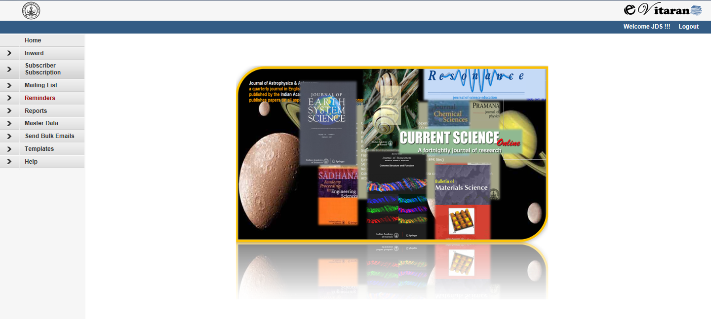

# Master Data

* Master Data is the key data of the system.
* This data can be maintained by only user with admin role.
* This data will be used by all the processes in the system.
* Following are the options for master data menu.
  + 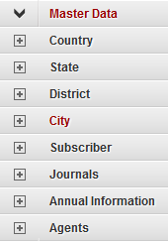Region
    - Country
    - State
    - District
    - City
  + Subscriber
    - subscriber type
  + Journal
    - Journal
    - Journal Groups
  + Annual Information
    - Journal Details
    - Volume Details
    - Annual Subscription Rate
    - Print order
  + Agents

## Region Data

Region data comprise of Country, State, District and City. The purpose of this option is to maintain the data at one place and use in other places to avoid mistakes and discrepancies.

### Country

#### Add Country

* To add the country, click on menu ‘Add Country’.
* Enter the new country name in the country field and press save.
* On save, a unique id will be generated for country. This id is for internal system reference.
* On save, ‘Edit’ button will be enabled.
* Press Edit for any modifications

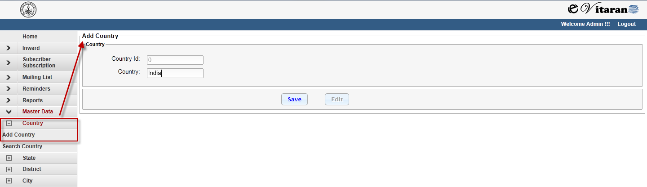

#### Search Country

* To search the country, use the menu item ‘Search Country’.
* This will navigate you to search country page
* Here enter country name of part of characters to in the country field.
* Press ‘Search’ button to get the search result.
* Press View/ Edit links to display and modify the Country

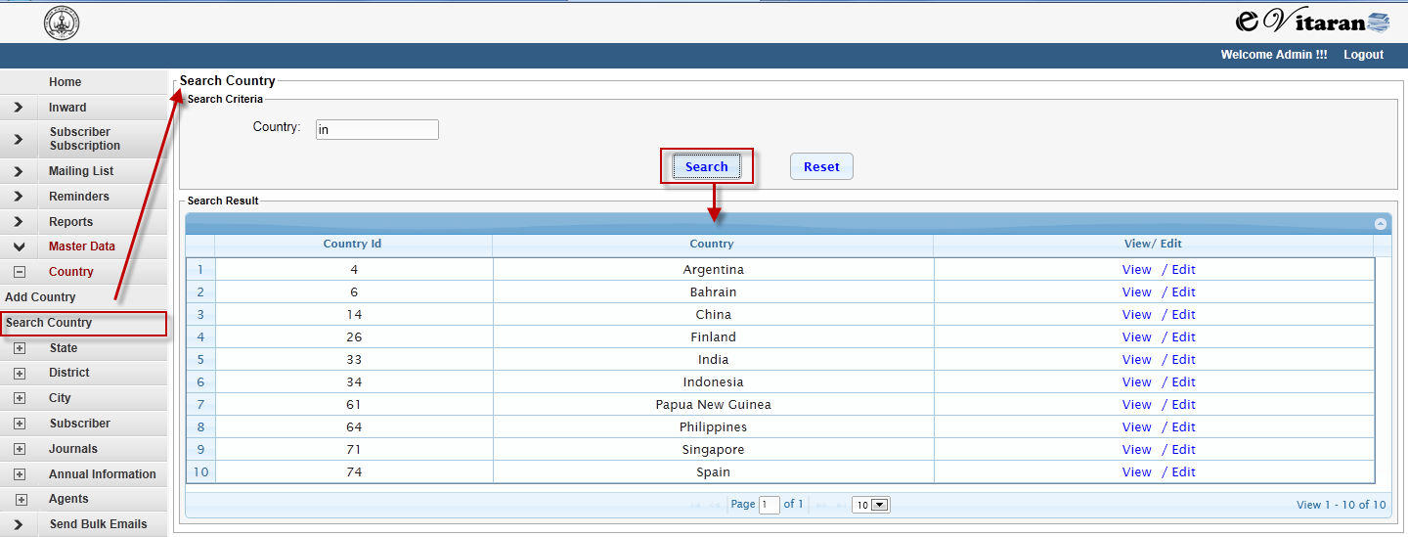

### State

#### Add State

* To add the state, click on menu ‘Add State’.
* Enter the new state name in the state field and press save.
* On save, a unique id will be generated for state. This id is for internal system reference.
* On save, ‘Edit’ button will be enabled.
* Press Edit for any modifications

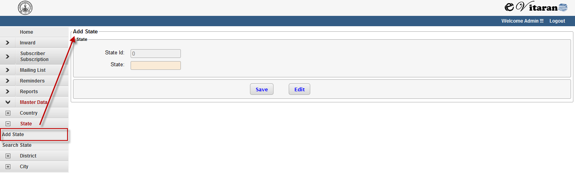

#### Search State

* To search the state, use the menu item ‘Search State’.
* This will navigate you to search state page
* Here enter state name of part of characters to in the state field.
* Press ‘Search’ button to get the search result.
* Press View/ Edit links to display and modify the state

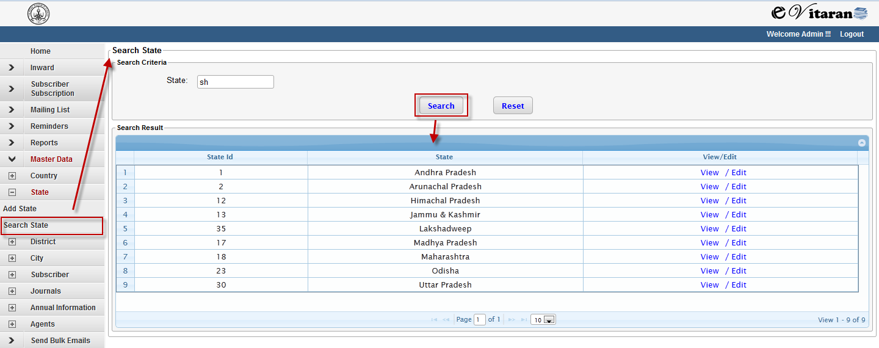

### District

#### Add District

* To add the district, click on menu ‘Add District’.
* Enter the new district name in the district field and press save.
* On save, a unique id will be generated for district. This id is for internal system reference.
* On save, ‘Edit’ button will be enabled.
* Press Edit for any modifications

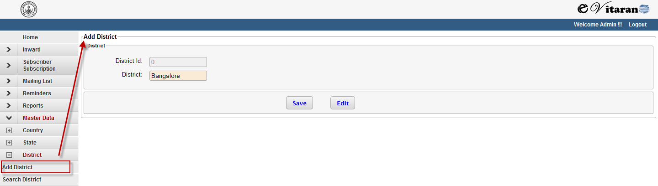

#### Search District

* To search the district, use the menu item ‘Search District’.
* This will navigate you to search district page
* Here enter district name of part of characters to in the district field.
* Press ‘Search’ button to get the search result.
* Press View/ Edit links to display and modify the district

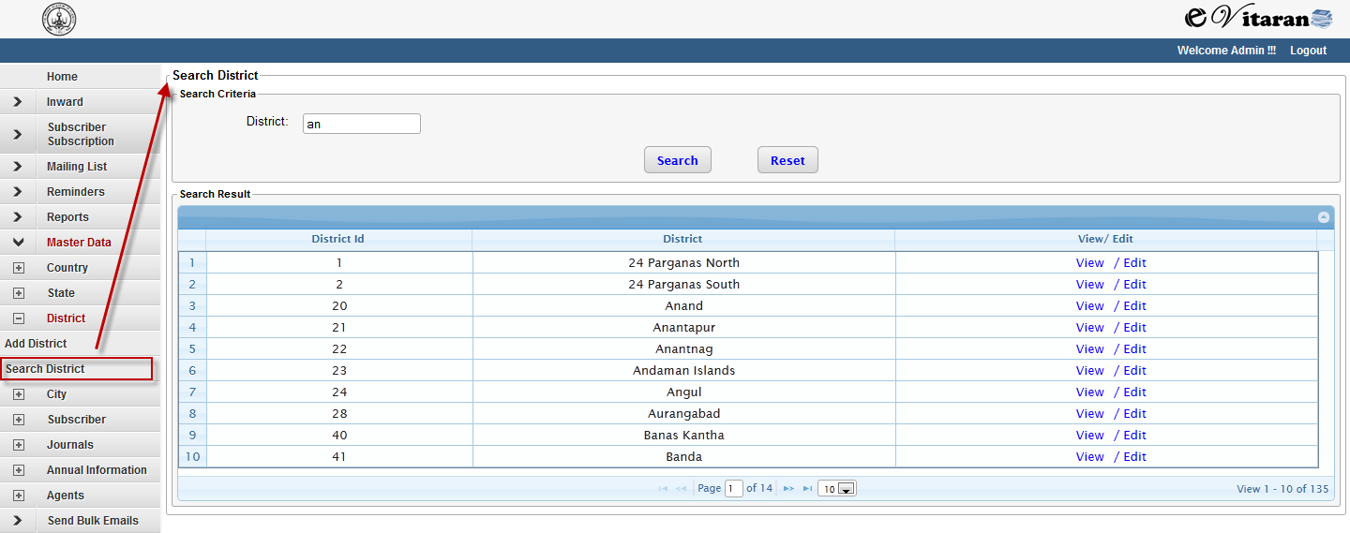

### City

#### Add City

* To add the city, click on menu ‘Add City’.
* Enter the new city name in the city field and press save.
* On save, a unique id will be generated for city. This id is for internal system reference.
* On save, ‘Edit’ button will be enabled.
* Press Edit for any modification

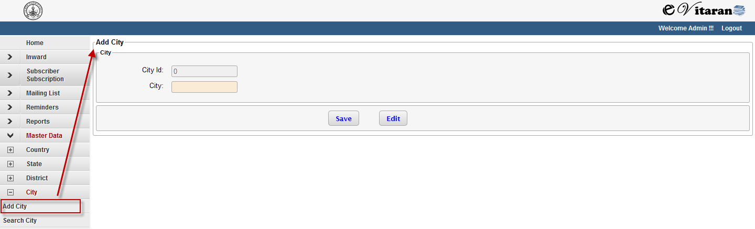

#### Search City

* To search the city, use the menu item ‘Search City.
* This will navigate you to search city page
* Here enter city name of part of characters to in the city field.
* Press ‘Search’ button to get the search result.
* Press View/ Edit links to display and modify the city.

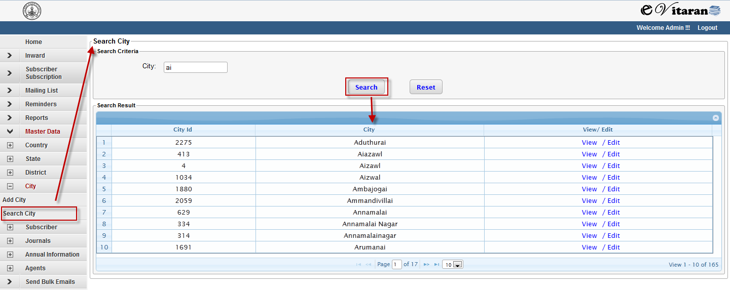

## Subscriber Master Data

Under Subscriber Master Data there is provision to maintain different subscriber type. The purpose of this option is to maintain the data at one place and use in other places to avoid mistakes and discrepancies.

### Subscriber Type

Subscriber Type defines that subscriber is of which category – Indian/ Foreign, Institute/ personal, Free/Paid. If there are any specific number of free copies given to type of subscriber, etc.

#### Add Subscriber Type

* To add the subscriber type, click on menu ‘Add Subscriber Type’.
* Enter the new subscriber Type name in the subscriber type field.
* Enter the new subscriber Type code in the subscriber type code field. This is maximum of 6
* character long
* Select the category of subscriber Indian/ Foreign, Institute/ personal, Free/ Paid from the drop down.
* Enter no of free copies associated with the free subscriber
* Enter any discount applicable for the subscriber type.
* Press save button.
* On save a unique id will be generated for subscriber type. This id is for internal system reference.
* On save, ‘Edit’ button will be enabled.
* Press Edit for any modifications

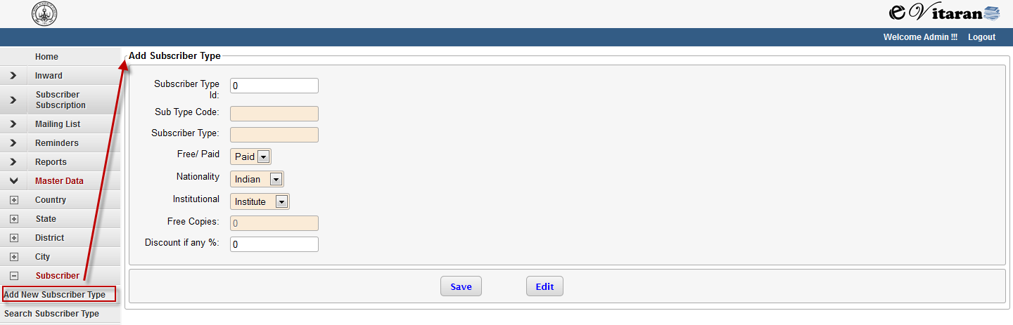

#### Search Subscriber Type

* To search the subscriber type, use the menu item ‘Search Subscriber Type.
* This will navigate you to search subscriber type page
* Here enter subscriber type code or subscriber type name or part of characters to in the Subscriber type code or subscriber type field respectively.
* Press ‘Search’ button to get the search result.
* Press View/ Edit links to display and modify the subscriber type information.

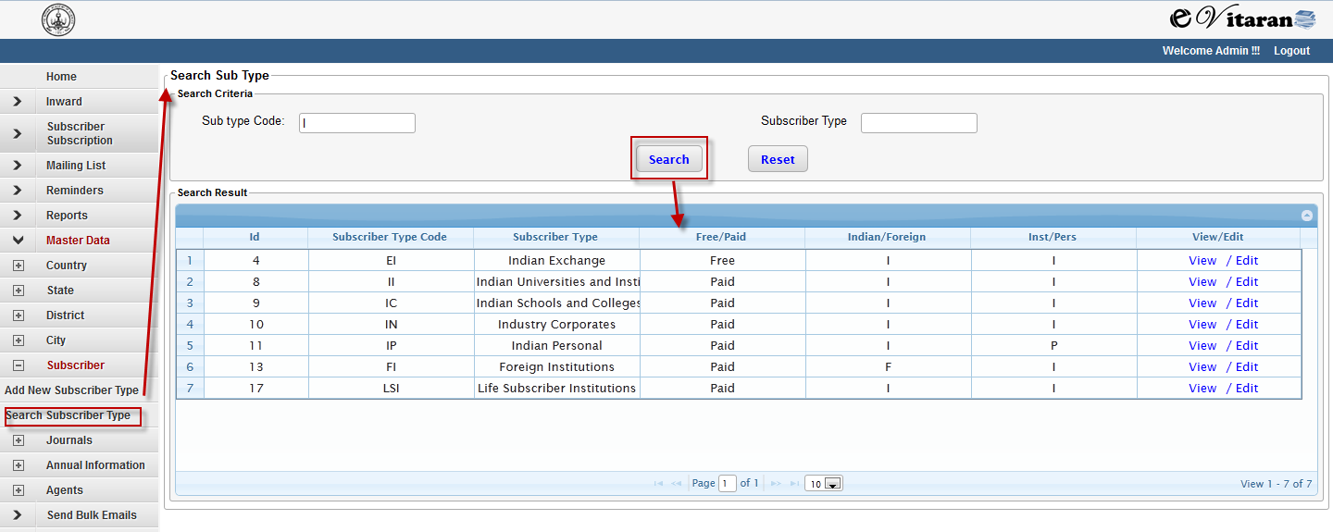

## Journal Master Data

Under Journal Master Data there is provision to maintain different Journal and Journal Group. The purpose of this option is to maintain the data at one place and use in other places to avoid mistakes and discrepancies.

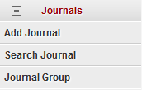

### Journal

This section is to maintain/ create Journal in the system. Here the unique information about the journal is maintained which is not changed annually. This comprises of Journal Name, Journal code (which can be used for short reference), ISSN number and Start Year.

#### Add Journal

* To add the journal, click on menu ‘Add Journal.
* Enter the new journal name in the Journal field.
* Enter the new journal code in the journal code field. This is maximum of 6 character long
* Enter start year and ISSN number
* Press save button.
* On save, a unique id will be generated for journal. This id is for internal system reference.
* On save, ‘Edit’ button will be enabled.
* Press Edit for any modifications

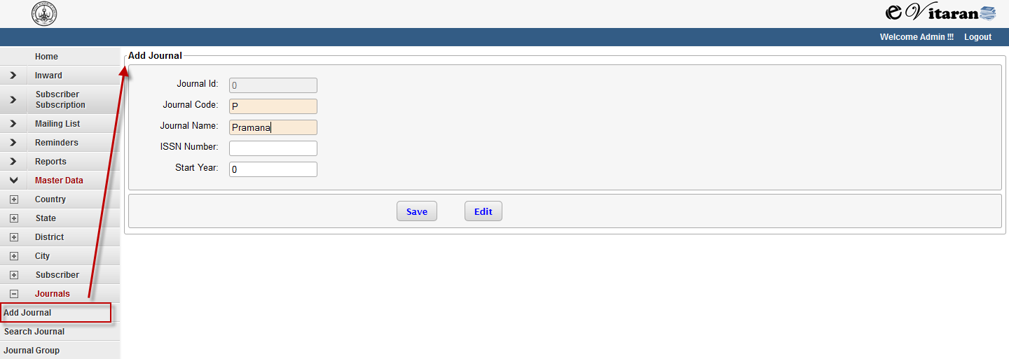

#### Search Journal

* To search the journal, use the menu item ‘Search Journal’.
* This will navigate you to search journal page
* Here enter journal code or journal name or part of characters to in the journal code or journal field respectively.
* Press ‘Search’ button to get the search result.
* Press View/ Edit links to display and modify the subscriber type information

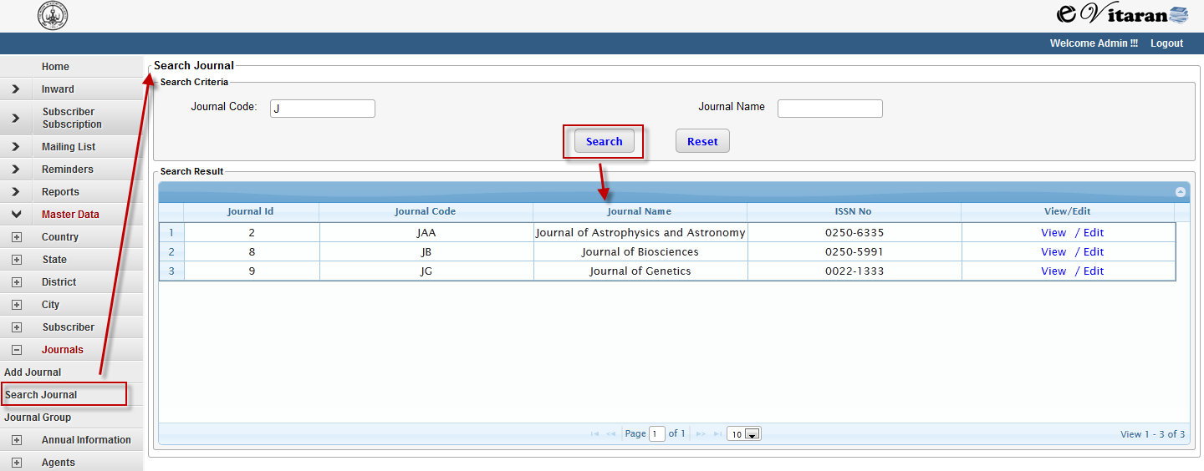

### Journal Group

This section is to maintain/ create Journal Group in the system. The purpose of the grouping the journal together is to define the price at group level and also to add a Group of Journal in a single click to subscription.

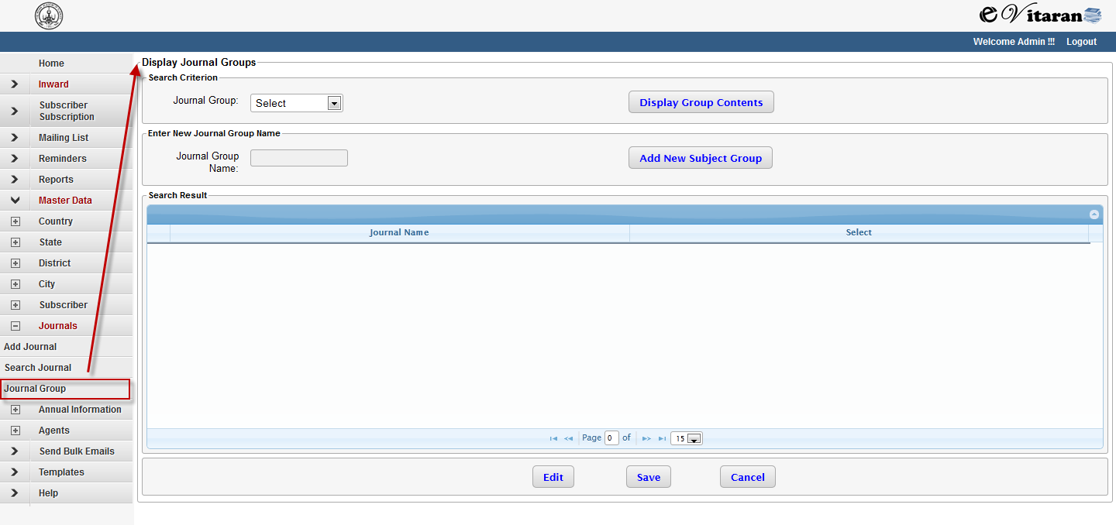

#### Add Journal Group

* To add the journal Group, click on menu ‘Journal Group’.
* On Click of ‘Journals Group’ option from the menu, ‘Display Journal Group’ form will be loaded.
* Click on new Add Subject Group.
* Journal Field Name will be enabled and all the list of journals will be loaded in the table below.
* Enter the name of the new Journal Group in ‘Journal Group Name Field’
* Press the Edit Button.
* The checkboxes will be enabled in the table.
* For Journals which needs to be added to the group select the checkboxes.
* Press the Button ‘Save.

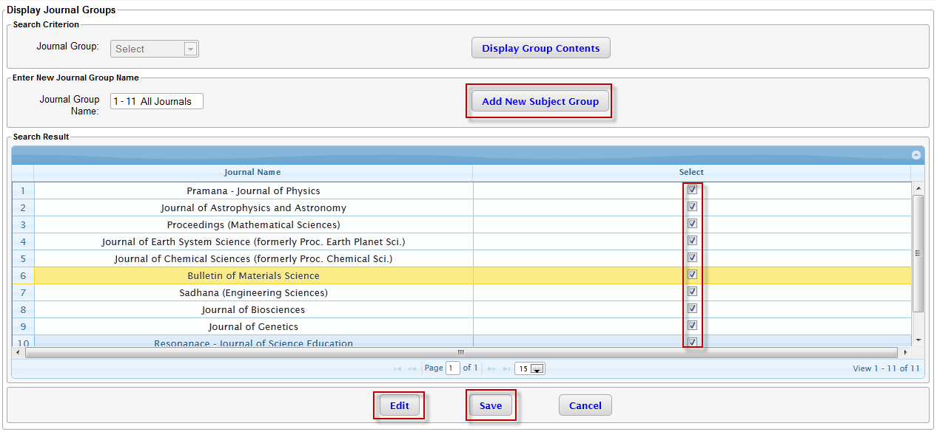

#### Display/Edit Journal Group

* To add the journal Group, click on menu ‘Journal Group’.
* This will navigate you to ‘Display Journal Group ‘page.
* Journal Group Drop down is enabled. All the available Journal Groups will be displayed in the drop down
* Select the Journal Group to be displayed from the dropdown.

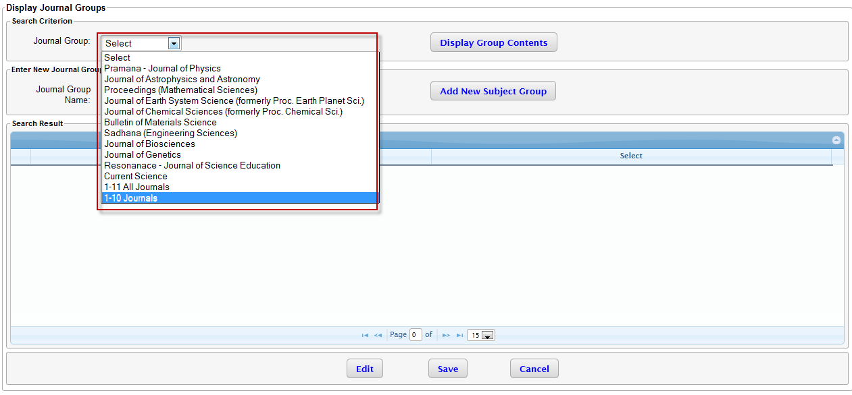

* Press button ‘Display Group contents’.
* List of Journals under the group will be loaded in the table.
* To modify the content for Journal Group, press button Edit.
* The checkboxes will be enabled in the table.
* For Journals which needs to be added to the group select the checkboxes. Deselect the check boxes for which Journal needs to be removed.
* Press the Button ‘Save.

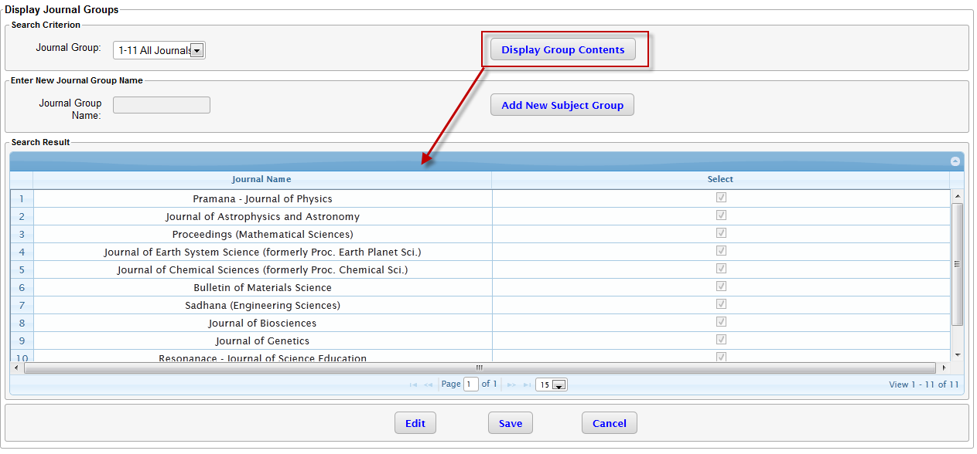

## Annual Journal Information

Certain annual information must be defined prior to the beginning of each year.

**Note:** If this information is not defined, then new subscriptions cannot be entered.

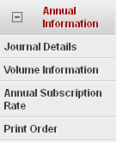

### Journal Details

Select the year from the year drop down menu and click on the “Get Journal Details” page. Press the “Edit” button if the existing information has to be edited or new information has to be added. The “Save” and “Cancel” buttons are enabled after the “Edit” button is pressed. After the required information has been added, press the “Save” button to save and “Cancel” if the changes have to be abandoned. The new changes will reflect immediately once changes have been saved.

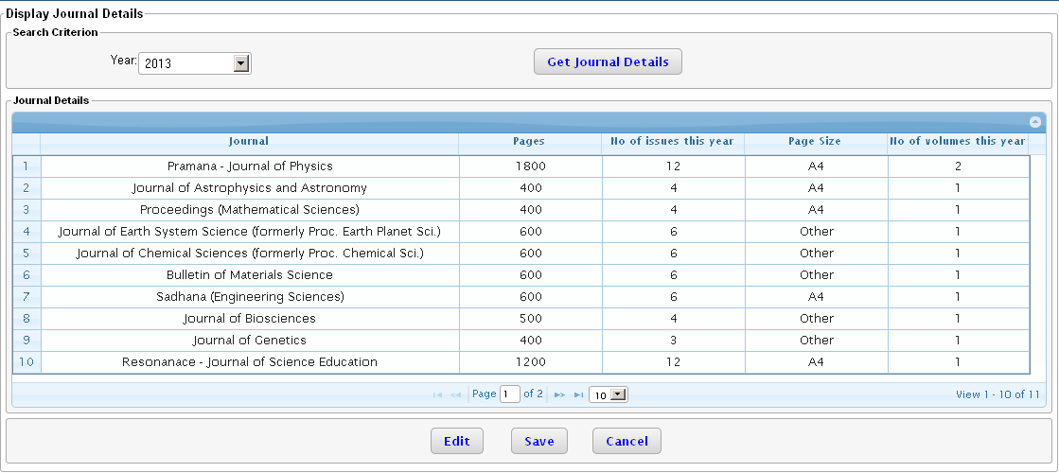

Note: The user needs to be careful while changing the “No of issues this year” and “No of volumes this year” since this information will also impact the mailing list generation.

Note: The user needs to be careful while changing the “Page Size” information. This information is used to club the list of journals to be included in a single label/ sticker while generating the back issue list.

### Volume Information

Once the information about the journals i.e. no of issues per year, no of volumes per year is entered, next we need to define the volume information. Select the year from the year drop down menu and select the journal for which the information needs to be entered. Click on the “Get Journal Volume Details” button and the table below will display the volume numbers and start month for the volumes. The “Volume Numbers” and “Start Month” can be defined using the “Edit” button. Information can be saved by the use of “Save” button.

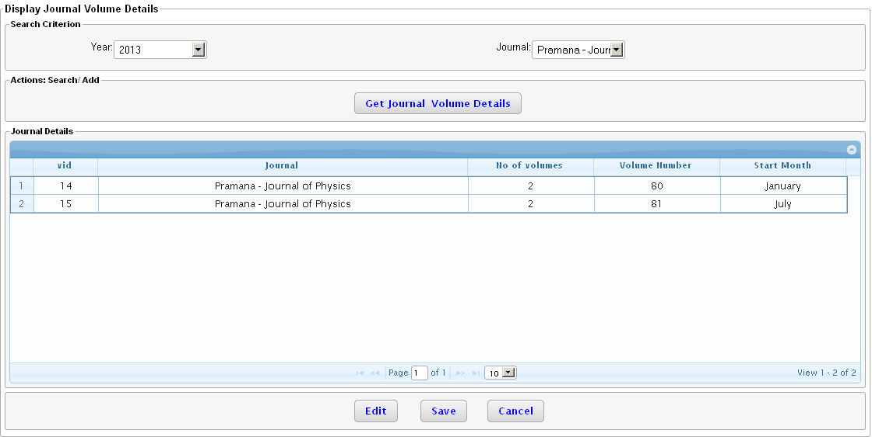

Note: The user needs to be careful when entering the volume numbers and the start month. This information is used for automatic generation of back issue labels.

### Annual Subscription Rate

There are 2 operations that can be performed on this screen i.e. viewing rates already defined and adding new rates.

Viewing of rates already defined: Select the year, followed by journal group, followed by the subscriber type and click on “Display Rates”. The table below will display the rates that have been defined.

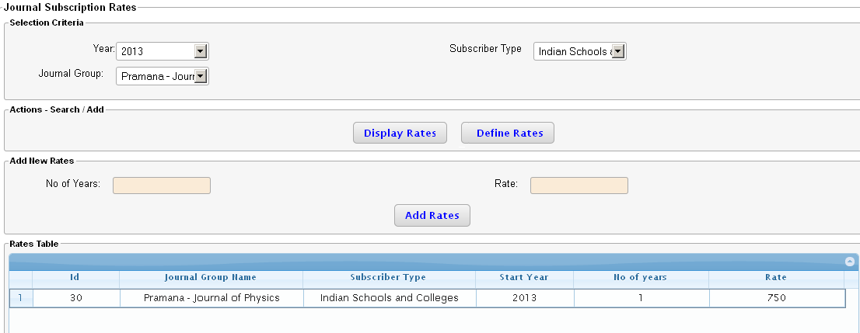

Note: This information is used to calculate the subscription rate. Hence this information once added cannot be deleted. The user needs to be careful while defining this information.

Addition of new rates: Select the year, journal group and subscriber group for which the rates have to be defined. Click on “Display Rates” to display the existing rates. Then click on “Define Rates”. The text boxes “No of Years” and “Rate” will be enabled. Clicking on the “Add Rates” button will add the rate for the selected journal group.

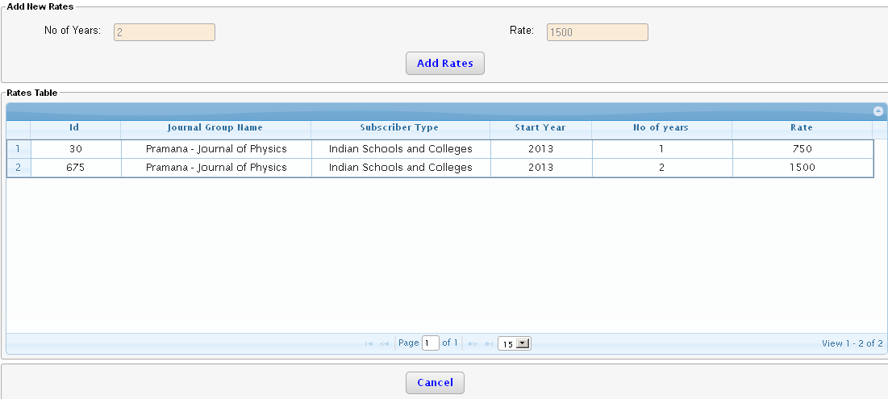

Note: The journal group is defined in

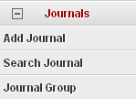

Note: The subscriber type is defined in

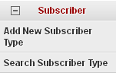

### Print Order

On this screen the print order information for each journal within that year can be defined. The information can be recorded per issue. The number of issues is derived from the information defined in the “Journal Details” screen. After selection of the “Journal”, “Year” and the “Volume Number” clicking on the “Search Print Orders” button displays the information in the table below. This information can be edited by pressing the “Edit”. This information can be saved by pressing the “Save” button.

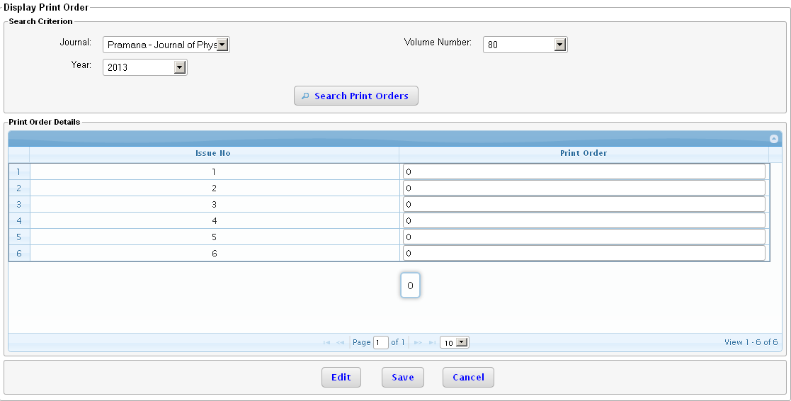

## 

## Agent Information

Information about agent can be added through the master data menu

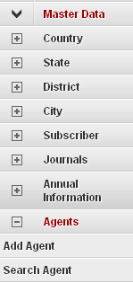

There are 2 options

* Add agent
* Search agent

### Add agent

A new agent can be added by clicking on the “Add agent” page. The fields marked in “RED” are mandatory and the user will not be allowed to save if this information is entered.

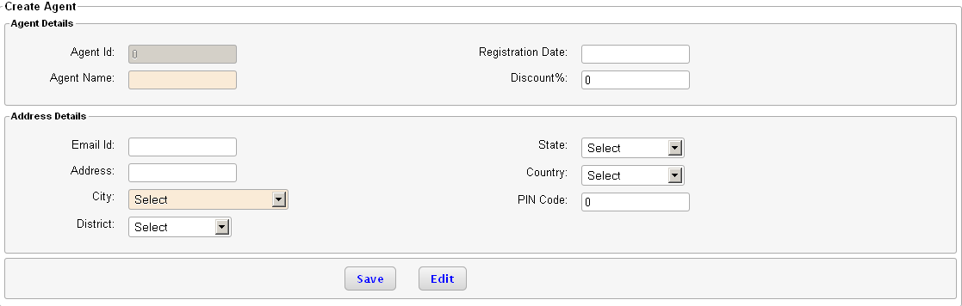

Clicking on “Save” saves the changes and “Edit” allows the user to edit the changes.

### Search agent

Information about an agent can be searched using this screen. Search can be performed using 2 parameters i.e. agent name or the city. Add the 2 search parameters and click on the “Search” button. The search results are displayed in the table below.

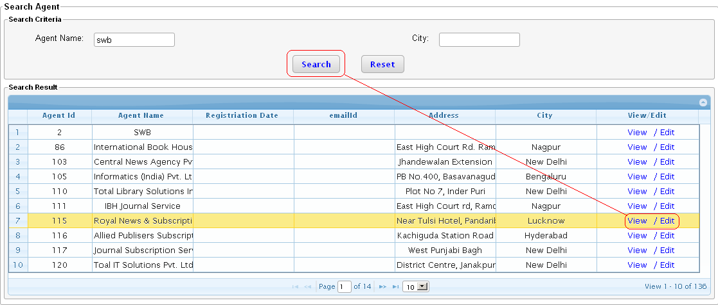

Further details about the agent can be viewed or edited by the links provided in the “View/ Edit” column. Clicking on either of the links will take the user to a add new agent page.

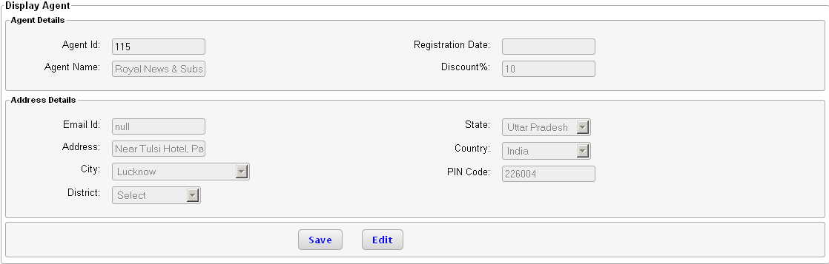

The user can edit the information on this page and save.

Note: The user needs to be careful in entering the information on this page especially the discount. The discount rate is used in calculation of the subscription rate for the agent.

# Inwards

The Processing in the circulation department starts on arrival of any mail/ letter/ call; this is called as “Inward”. The inward can be a hard or soft letter. For all the inwards coming to the department a unique system generated number is given. This is called as Inward number. This number is written back on the inward paper. For all the received inwards an acknowledgement letter is sent to the requestor.

Inwards can consist of the following i.e request for renewal, new subscription, reprints, advertisements, etc. then the cheque/ DD/ MO. If any financial transaction is involved, then the inward is sent to account department. Return for inward is created in case if the cheque or DD is not materialized. When the DD/cheque is encashed, the details are updated in inward and required action is done.

Out of all the coming inwards the important inward for circulation department are the following.

1. New Subscription
2. Subscription renewal
3. Request for invoice
4. Missing issue list
5. Change of address

Steps for processing inward

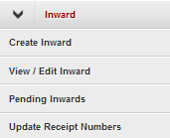

## Create Inward

* To enter the inward in the system use menu, Inward 🡪Create Inward.
* New inward screen will come up

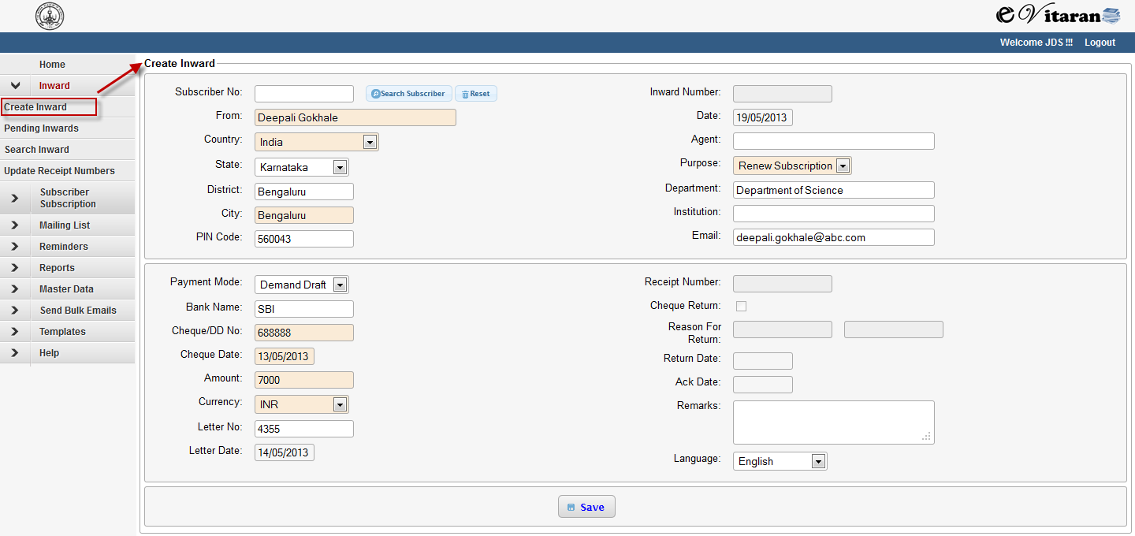

* From, Purpose and city are the mandatory fields.
* Based on the type of inward purpose can be selected.

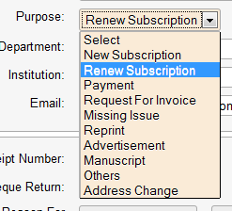

* If the inward is coming from an Agent, then the selection of Agent is must.
* Payment details can be maintained using the options given in the given fields.

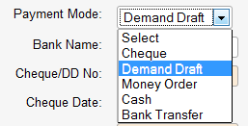

* There is also an option to select the subscriber while entering inward.
* Based on the entered data, subscriber is suggested.
* In case subscriber cannot be identified based on entered data, the search option for subscriber is provided.
* Reset Button is provided beside the select subscriber screen, this is to reset the selected subscriber.

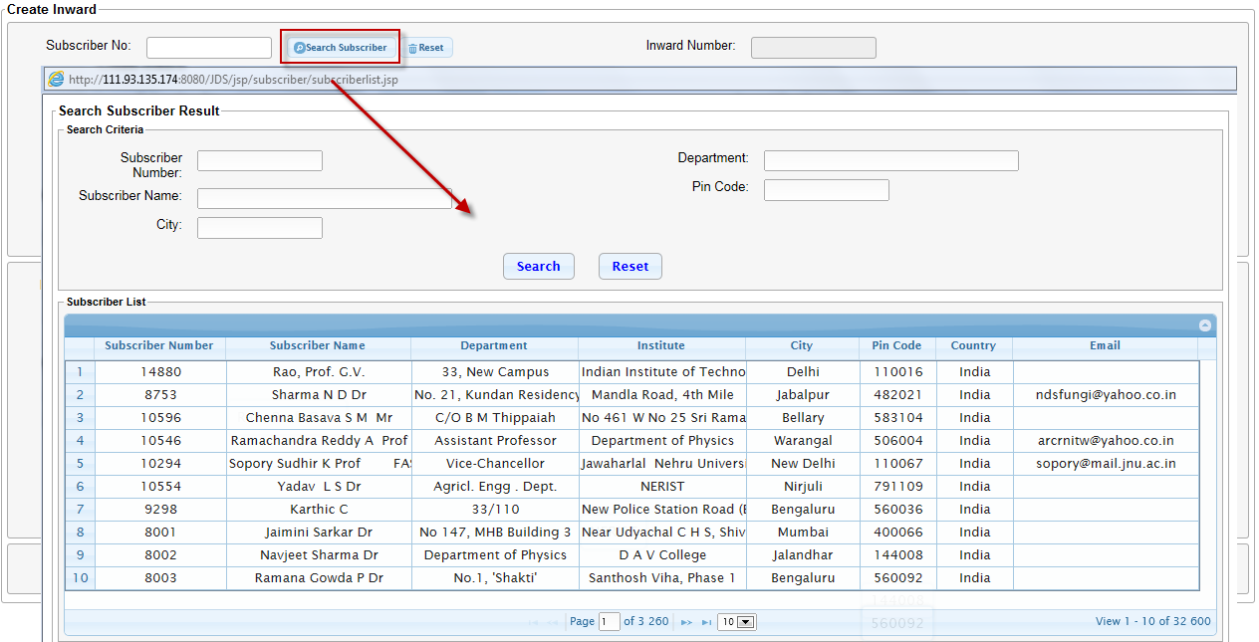

* After entering the complete information related to inward, press ‘Save’ button to save the inward
* On saving the inward, new inward number is generated. This can be viewed in the inward number field.
* On saving the inward view inward page is loaded.

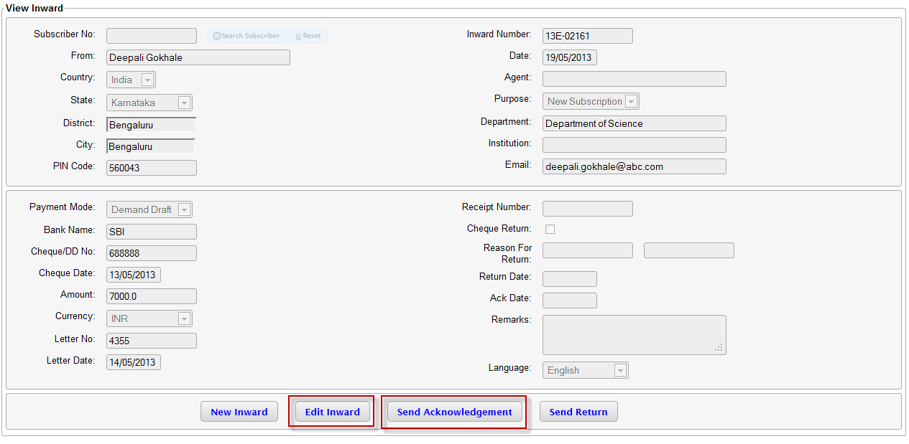

* You can use the ‘Edit Inward’ button to modify, if any incorrect information is maintained or to complete the remaining information.
* Press the ‘Send Acknowledgement’ button to send the acknowledgement.
* On pressing the ‘Send Acknowledgement’ button, ‘Send Acknowledgement screen is loaded.
* Here the acknowledgement content will be displayed as per the type of inward.

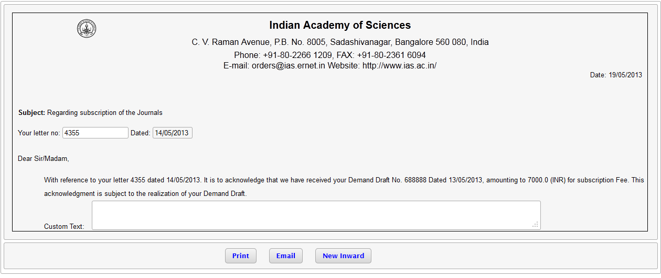

* Fields are provided to enter letter number, letter date and custom text.
* Press ‘print’ and ‘email’ buttons to send acknowledgement via print and email medium respectively.
* Below mentioned sample text will send as acknowledgement.

#### 

* New Inward Button is there to navigate to the ‘Create Inward’ screen.

## View/ Edit Inward

* To view/Edit inward, the first step is to search inward.
* Inward can be searched using fields ‘Inward Number’, ‘Cheque Number’, ‘City’ and ‘Date Range’.
* Use View/ Edit link in search result table to open the inward screen in display or edit the inward respectively.

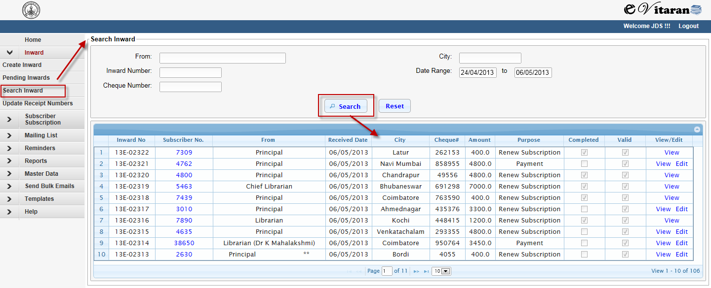

* In Edit inward screen the receipt number can be updated.

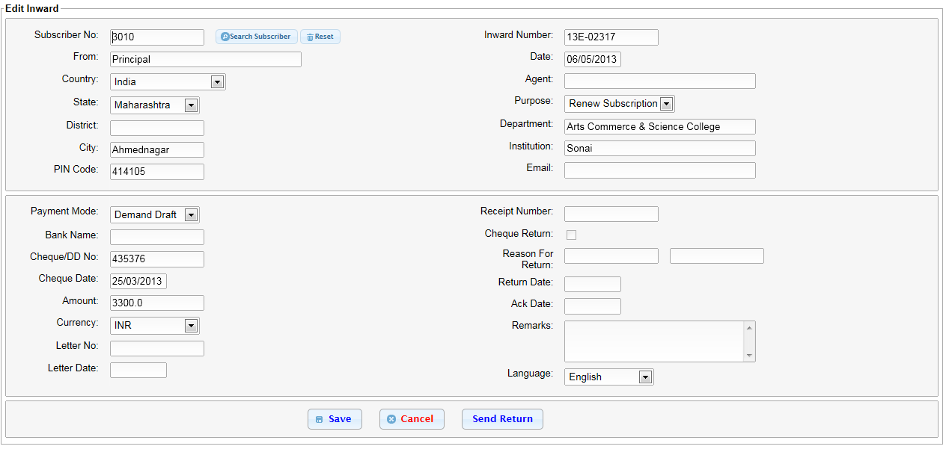

* After modifying required information, press the save button.
* From Edit Inward screen, press the ‘Send Return’ button to check/DD Return.

## Send Return

* Press button ‘Send Return’ from Edit or Display screen of Inward. This will navigate to the ‘Cheque/ DD return page.
* Here select the reason of return and press ‘Save’.

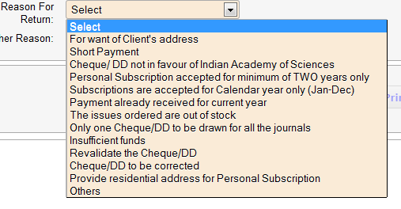

* On Save, ‘Print’ and ‘Email’ button will be enabled.
* Press ‘print’ and ‘email’ buttons to send return via print and email medium respectively.
* Below mentioned sample text will send for ‘Send Return’.
* Selected reason of return will be updated in the mail.



## Pending Inwards

* This screen lists all the inwards which are not processed and completed.
* Use ‘Pending Inward’ Menu option to navigate to pending inward screen.
* Default all the pending inwards will be listed.
* Pending inwards can be filtered on purpose, using purpose dropdown list.

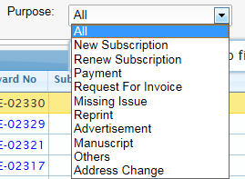

* Select the inward and click the Next button for further processing of Inwards.
* Further processing of Inward will be covered in the respective section of process flow. Missing Issue, New Subscription, renew Subscription, Address Change, Request for Invoice, etc.

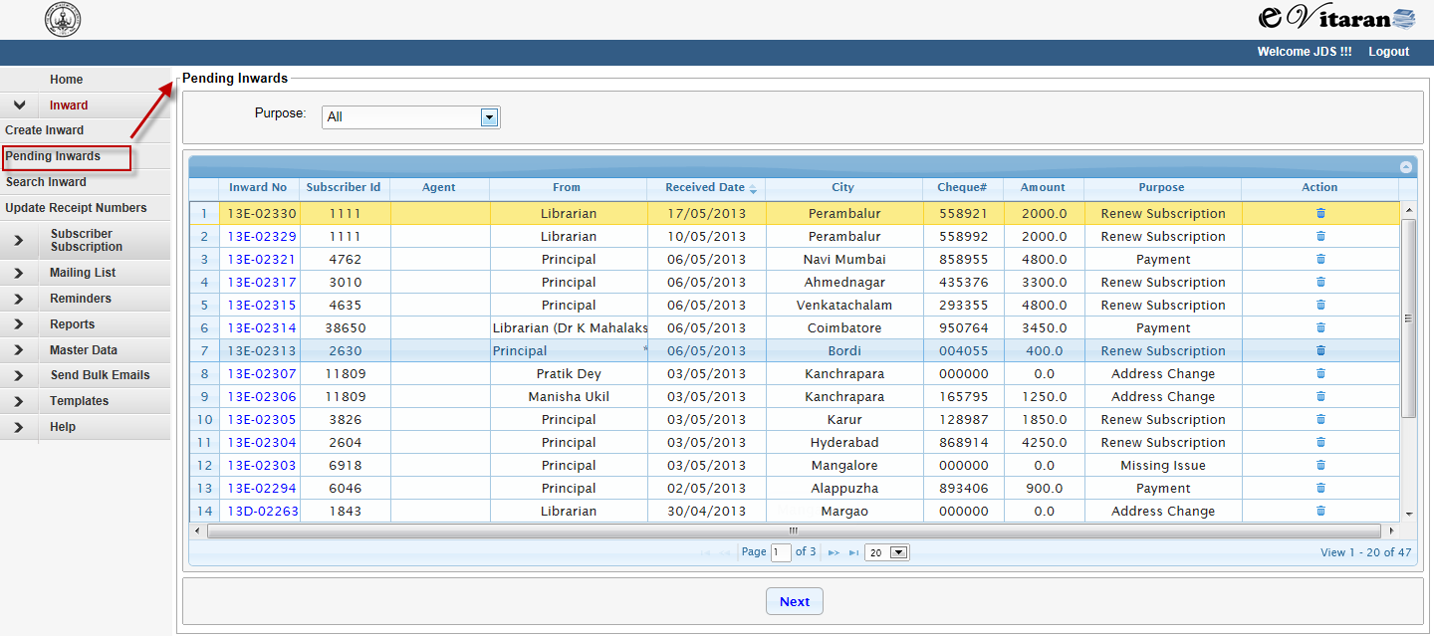

## Update Receipt Number:

* Update receipt Number flow is used to update the Receipt number coming from accounting department to Inward.
* Use menu ‘Update Receipt Number’ to navigate to update receipt number screen.
* Get the files coming from accounting system (Tally) in XML format and save.
* Press button ‘Add Files’, on the screen.

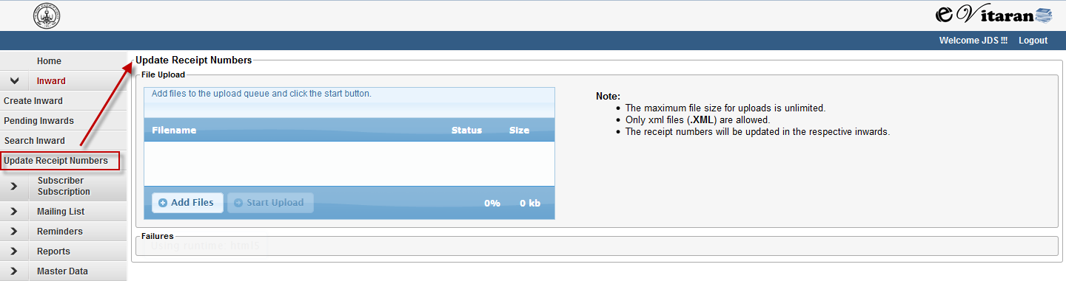

* On Pressing the Add Files Button, a file selection window will appear.
* Select the required file and press ‘Open’.
* The file will be loaded to the screen
* Press ‘Start Upload’ button to update the receipt numbers to the respective inwards.
* Success or failure message will be shown as per the status of inward.

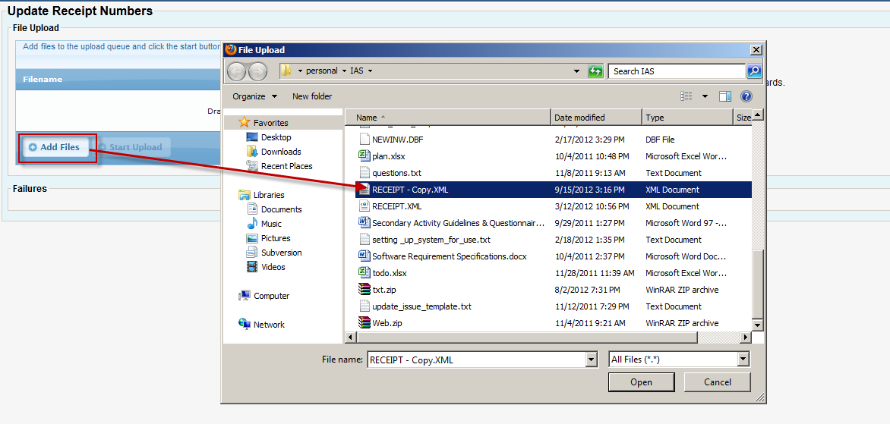

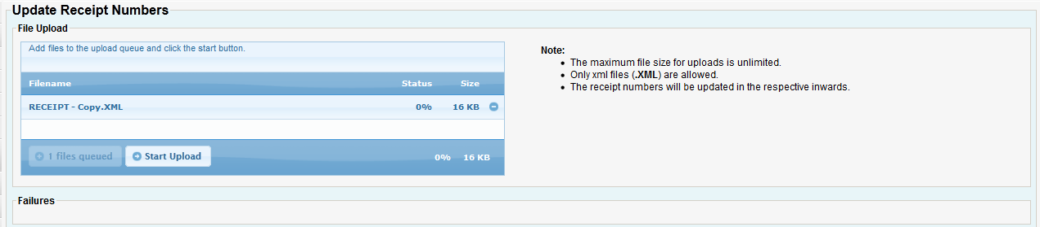

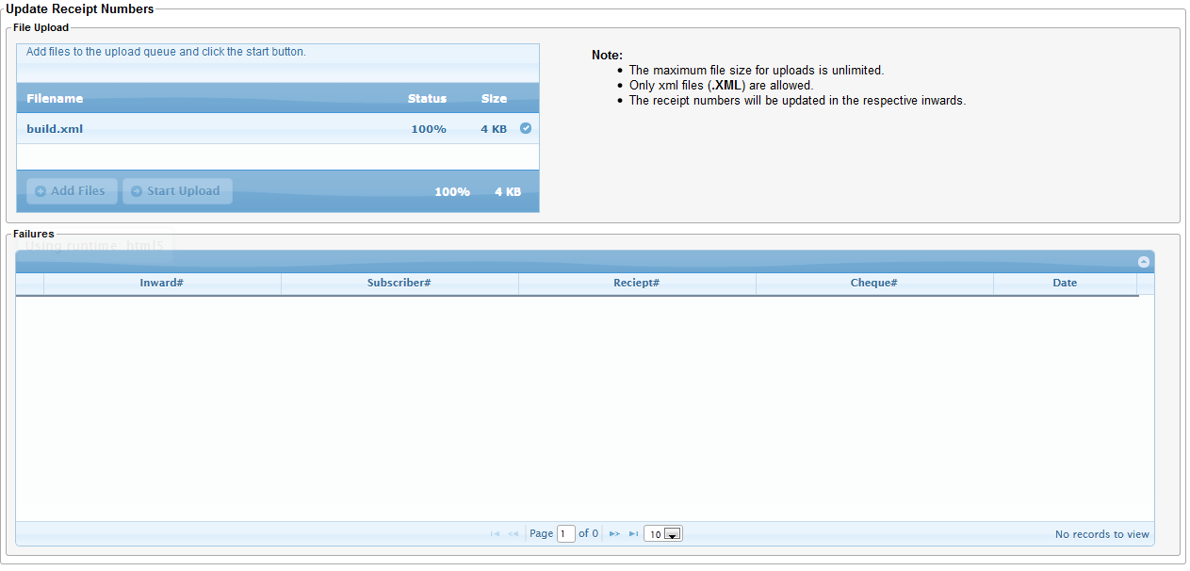

# Subscriber

## Edit Subscriber

To modify any subscriber information like address, email, phone, address follow the below steps. It is always recommended that user always create an inward of type “Address Change” before making an changes to subscriber address.

* Navigate to subscriber/subscription on the left menu and click on “Search Subscriber”

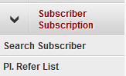

* Enter any of the search criteria like city, subscriber number, name, email, pin code. More the number of fields are filled better the search results, otherwise a large number of subscribers may get displayed after the search

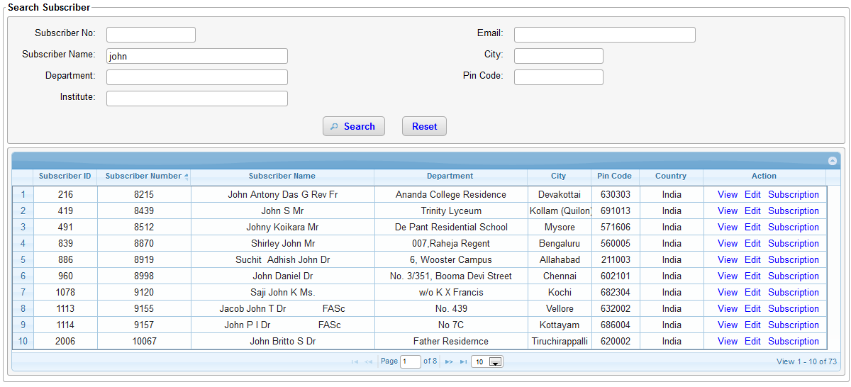

* Click on “Edit” link under the Action column.
* Now the subscriber screen is displayed in edit mode. Make changes to fields are required.
* If the deactivate checkbox is selected the subscriber is marked “inactive” and all his/her subscription will be marked inactive.
* Click on Save to submit the changes
* Click Cancel to revert any changes that were made.

## View Subscriber Details

To view detailed information like address, subscriptions, invoices, cheque returns, reminders, missing issue claims and inwards about a subscriber follow the below steps.

* Navigate to subscriber/subscription on the left menu and click on “Search Subscriber”



* Enter any of the search criteria like city, subscriber number, name, email, pin code. More the number of fields are filled better the search results, otherwise a large number of subscribers may get displayed after the search



* Click on a row or “view” link

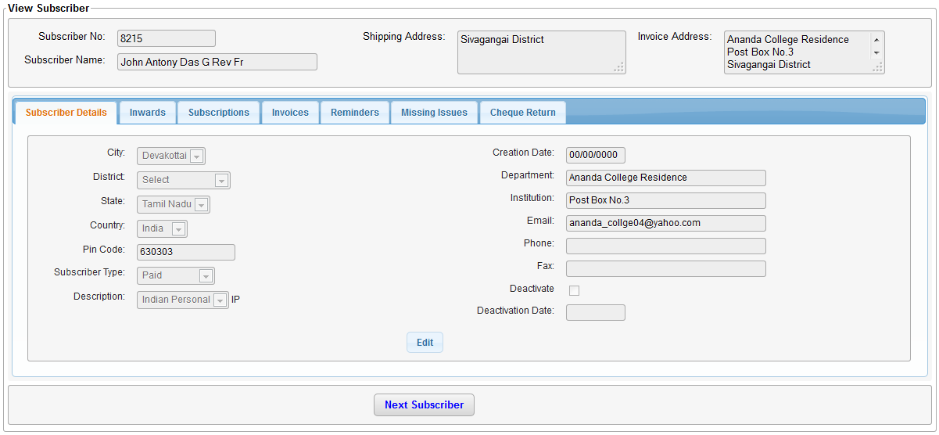

* Different tabs are displayed for each type of information about the subscriber. Click on any tab to view further details.
* Under the subscriber details tab, click on “Edit” button to modify subscriber address, state, city, country etc.
* Clicking on “Next Subscriber” will display the next subscriber details, this helps to traverse through the subscribers database.

### View subscription

All subscription information for a subscriber is available under the subscription tab. To know how to navigate to subscription tab refer to view subscriber details section

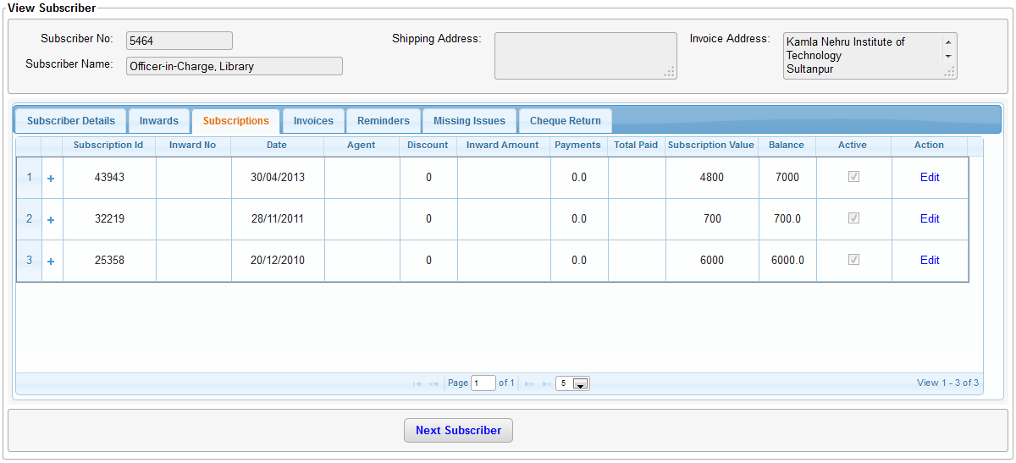

### Edit subscription

Click on “Edit” link on the subscriptions tab as shown above for the edit subscription page to be displayed.

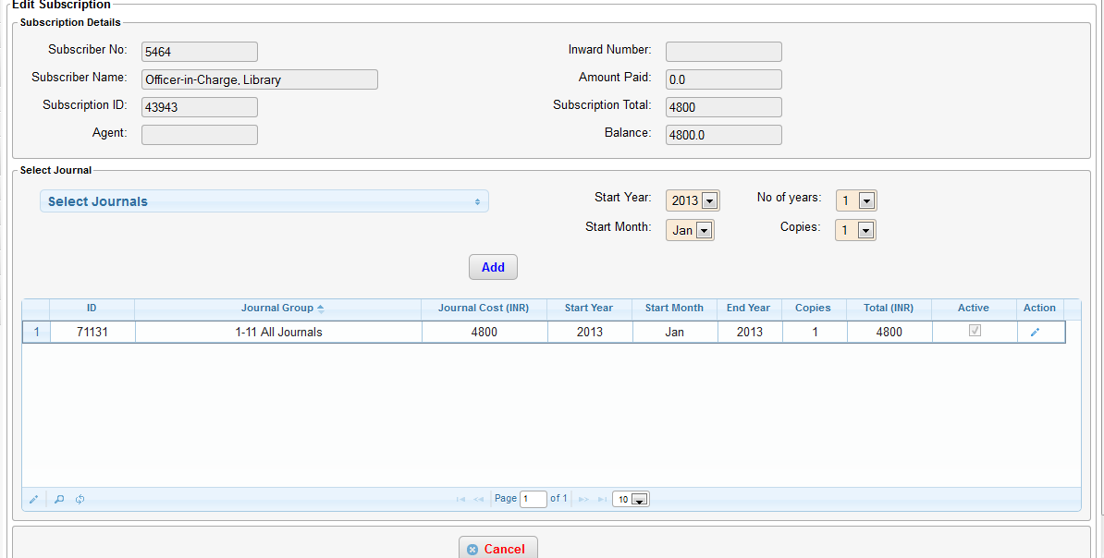

* Click on the pencil icon under the action column to edit each journal information (shown below).

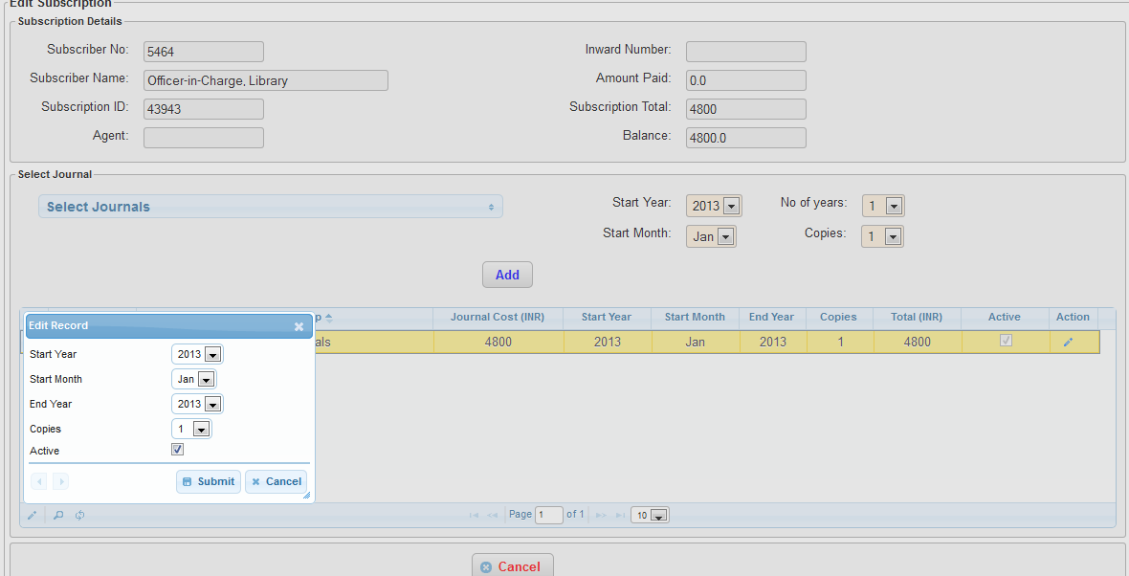

* Any changes made on the window gets saved immediately to the database. Please be sure before making any changes here.
* To add a journal that does not already exist, select the journal from the drop down, select start year, start month, number of years and copies. Click on Add. The new journal will get added to the back issue list
* Clicking on Cancel will only navigate away from this page. Any changes that were made will not be cancelled/reverted.

# Please Refer List

Please refer list creates invoices for the upcoming year for subscribers having a valid subscription. These invoices can be then sent to the subscriber via email of post. This feature is generally used to remind subscribers to renew their subscription for the upcoming year. To generate this list follow these steps.

* Click on subscriber/subscription on the left menu. Then click on “Pl. Refer list” as shown in the below picture.

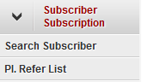

* Now select the medium through which the invoice should be sent.
  + Email Only: The invoice will be sent to all subscribers that have an email id in the system
  + Print Only: The invoice for all subscribers that do not have an email id in the system will be printed.
  + Print All: The invoice for all subscribers get printed even though they may have a valid email id.

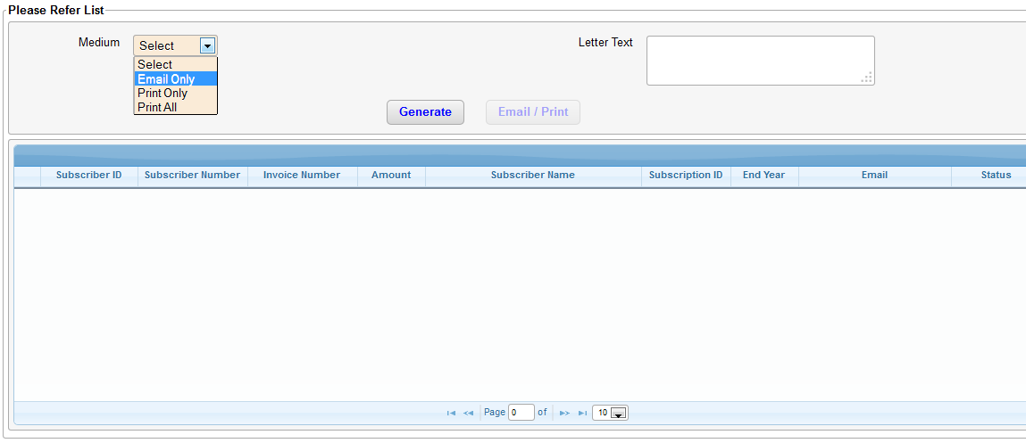

* Enter any custom text that you wish to convey to the subscribers in the “Letter text” field.
* Click on “Generate”
* The list is now generated for all valid subscribers.
* Click on “Email/Print” to either start sending emails or print each invoice in the list.

# Mailing\ Back Issue List

Mailing list is list of labels/ stickers required for sending the issue of the Journal. This section contains two things mailing list and Back Issue List.

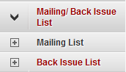

## Mailing List

Mailing list is list of labels/ stickers required for sending the current issue of the Journal. Mailing list is generated based on the publication date of a Journal. This list contains all the set of subscribers who has subscriber for the particular Journal and subscription is valid for that issue.

In mailing List Generation and Reprint of Journals is divided into two screens

1. Generate and Print Mailing List
2. Display and Reprint Mailing List

### Generate and Print Mailing List

* Generate and print mailing list option is used to generate mailing list for the first time.
* For this use submenu item ‘Generate Print Mailing List’
* On Click of this ‘Generate and Print mailing List page will be loaded.
* Select Journal Name, Year, Month, Volume and Issue number for which mailing list is to be generated.

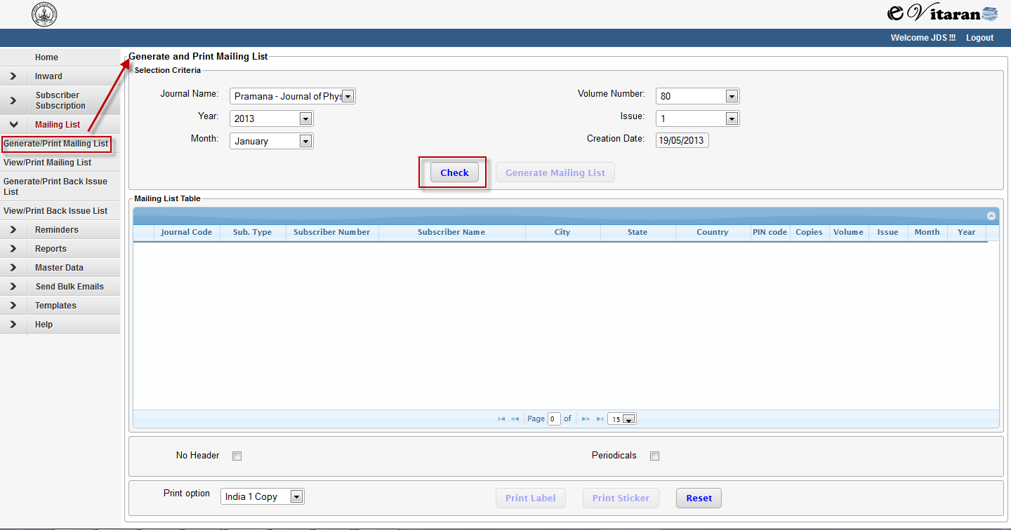

* Click on check button. This will give message if the mailing list is already generated

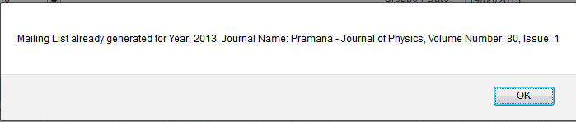

* If mailing list is not generated then the ‘Generate mailing list button will be enabled.

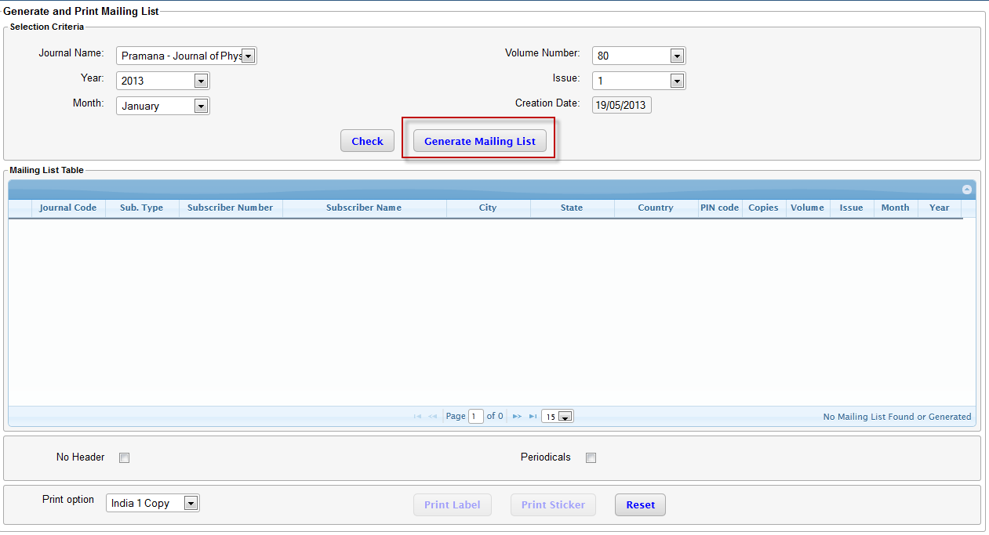

* Press button ‘Generate Mailing List’. The mailing list will be generated and loaded in the table below.
* Once mailing list is generated, the ‘Print Label’ and Print Sticker buttons will be enabled.

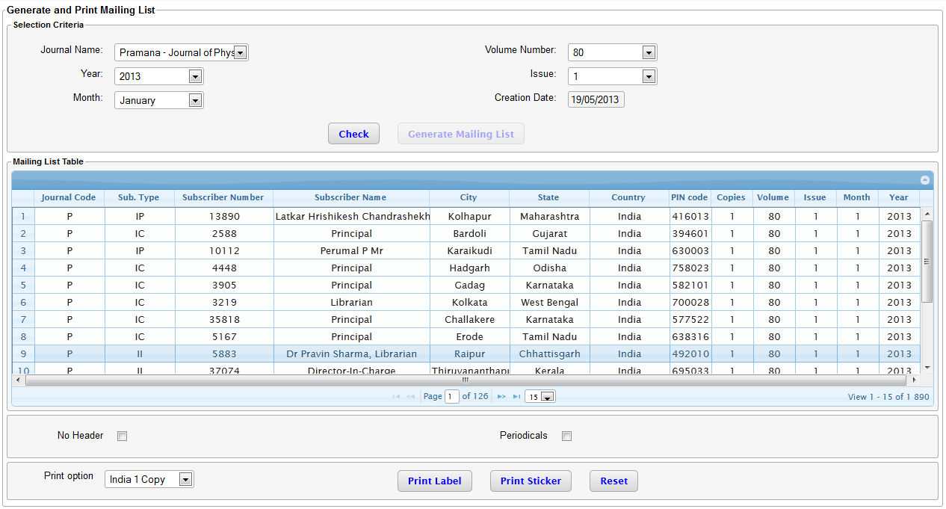

* Before printing select the ‘No Header’ Checkbox if Header is not required in Label.
* Check the periodical checkbox if the string ‘PERODICAL’ is to be printed in the label.
* Different print group are available to print the mailing list under ‘Print Option’.
  + India 1 Copy
  + India Extra
  + Foreign
* Labels and stickers will be printed in the form of PDF.

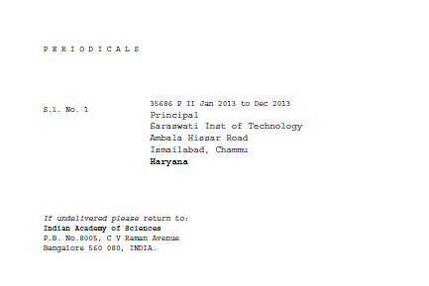

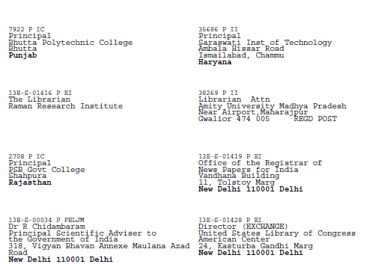

* Reset button to be used to reset the content of the screen.
* It is possible to search with in the mailing list on all the selection parameters of the table.

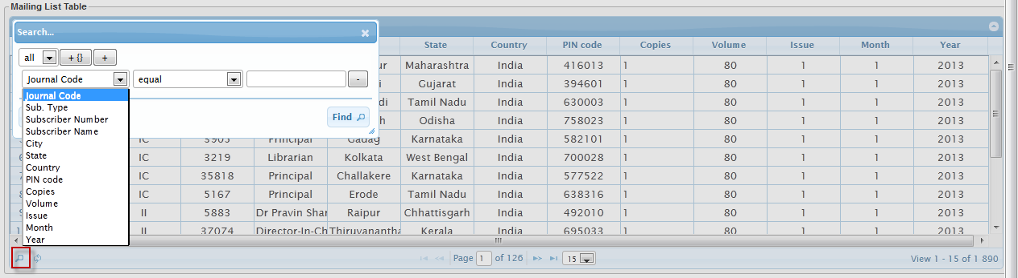

### Display and Print Mailing List

* View/ Print mailing list option is used to generate mailing list for reprinting of Labels.
* For this use submenu item ‘View/ Print Mailing List’
* On Click of this ‘View/ Print mailing List page will be loaded.
* Select Journal Name, Year, Month, Volume and Issue number for which mailing list is to be printed.

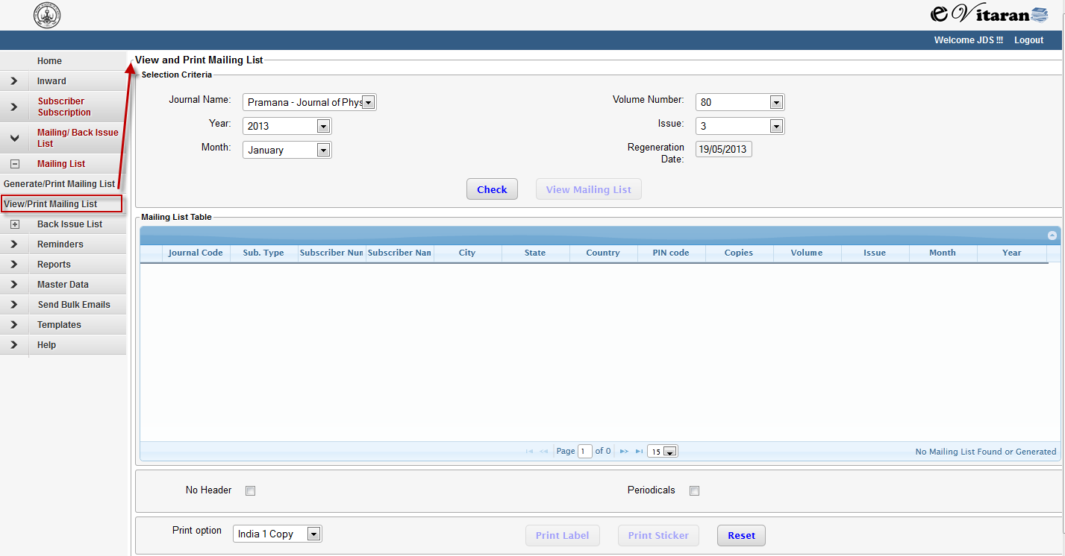

* Click on check button. This will give message if the mailing list is not yet generated

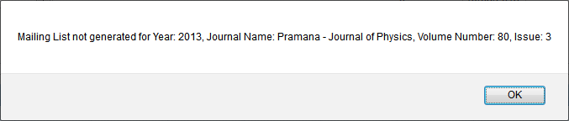

* If mailing list is already generated then the ‘View Mailing List’ button will be enabled.

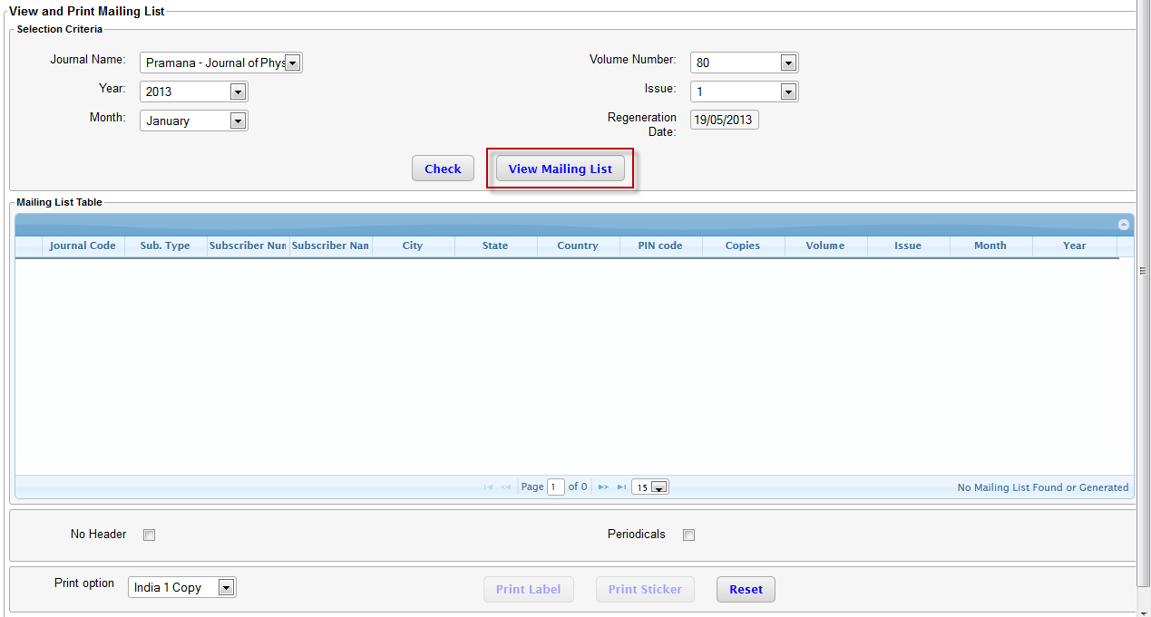

* Press button ‘View Mailing List’. The mailing list will be loaded in the table below.
* Once mailing list is generated, the ‘Print Label’ and Print Sticker buttons will be enabled.

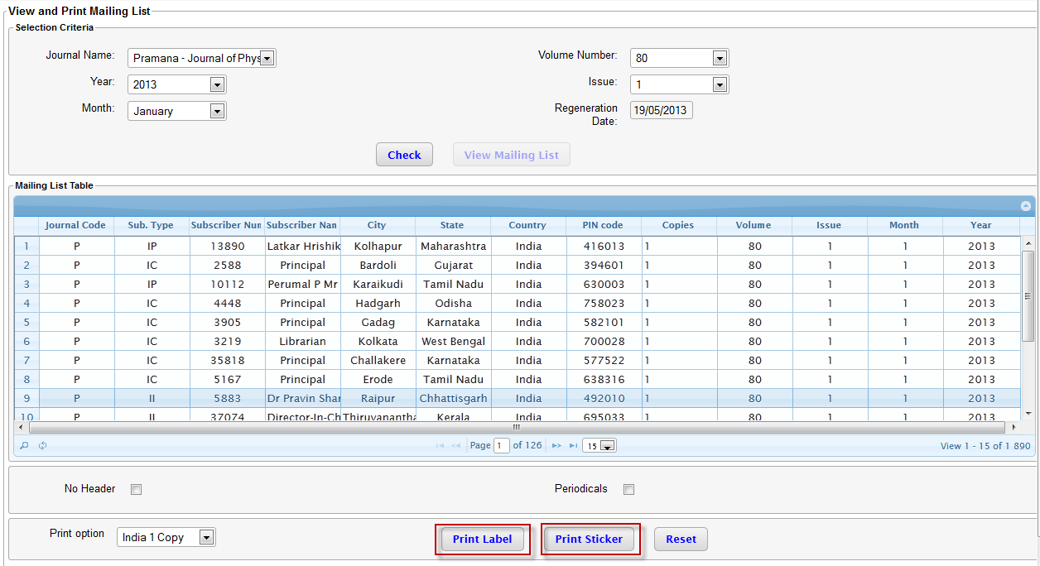

* Before printing select the ‘No Header’ Checkbox if Header is not required in Label.
* Check the periodical checkbox if the string ‘PERODICAL’ is to be printed in the label.
* Different print group are available to print the mailing list under ‘Print Option’.
  + India 1 Copy
  + India Extra
  + Foreign
* Labels and stickers will be printed in the form of PDF.





* Reset button to be used to reset the content of the screen.
* It is possible to search with in the mailing list on all the selection parameters of the table.



## Back Issue List

Back Issue list is list of labels/ stickers required for sending the back issues of the Journals for the subscribers who joins in between the subscription cycle. The back Issue list contains the list of all the issues of the journal for which mailing list is already generated.

In Back Issue List Generation and Reprint of Journals is divided into two screens

1. Generate and Print Back Issue List
2. View and Print Back Issue List

### Generate and Print Back Issue List

* Generate and print back issue list option is used to generate back issue list for the first time.
* For this use submenu item ‘Generate /Print Back Issue List’
* On Click of this ‘Generate /Print Back Issue List’ page will be loaded.
* The Subscriber Number dropdown will be prefilled with the subscriber numbers for which back issue list is to be generated

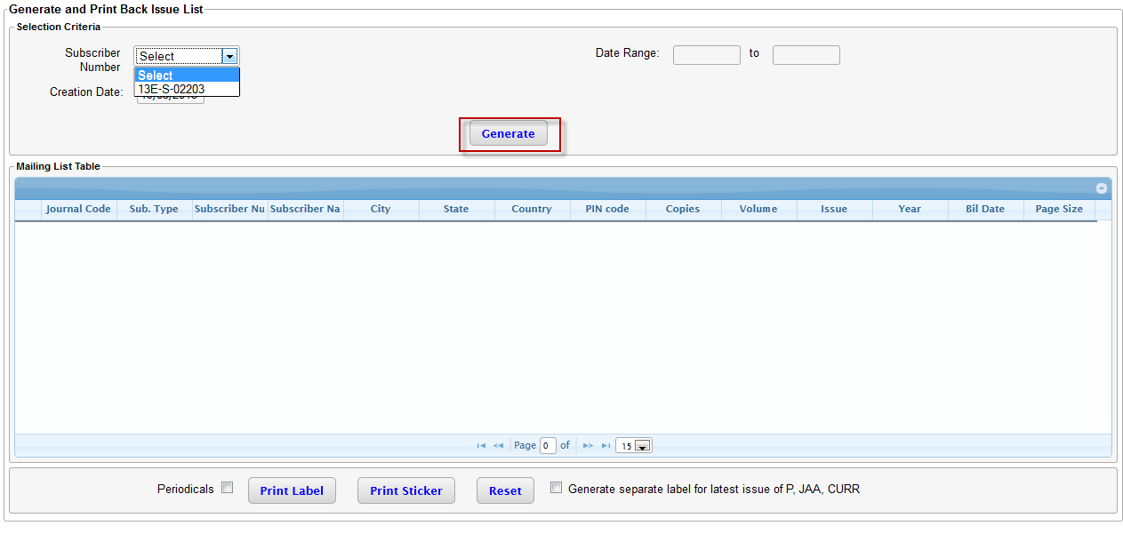

* Select Subscriber Number or Date Range for which back issue list is to be generated.
* Press button ‘Generate’ to generate the back issue list.

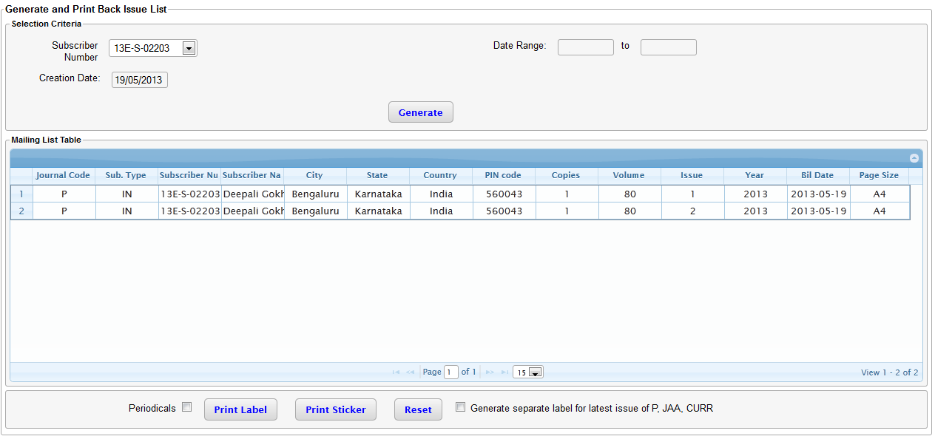

* Use ‘Print Label’ and ‘Print Sticker’ button to print the back issue.
* Back issue will be printed in the form of PDF.
* The journals will be grouped to form only one or two labels based on page size for a back issues.

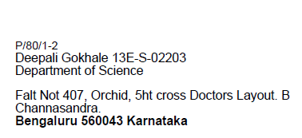

* Use checkbox ‘Generate separate label for latest issue of P, JAA, CURR’ for generating separate label for Pramana, Journal of Astronomy and Astrophysics and Current Science.

### Display and Print Back Issue List

* View and print back issue list option is used to print back issue list which is already generated.
* For this use submenu item ‘View /Print Back Issue List’
* On Click of this ‘View /Print Back Issue List’ page will be loaded.

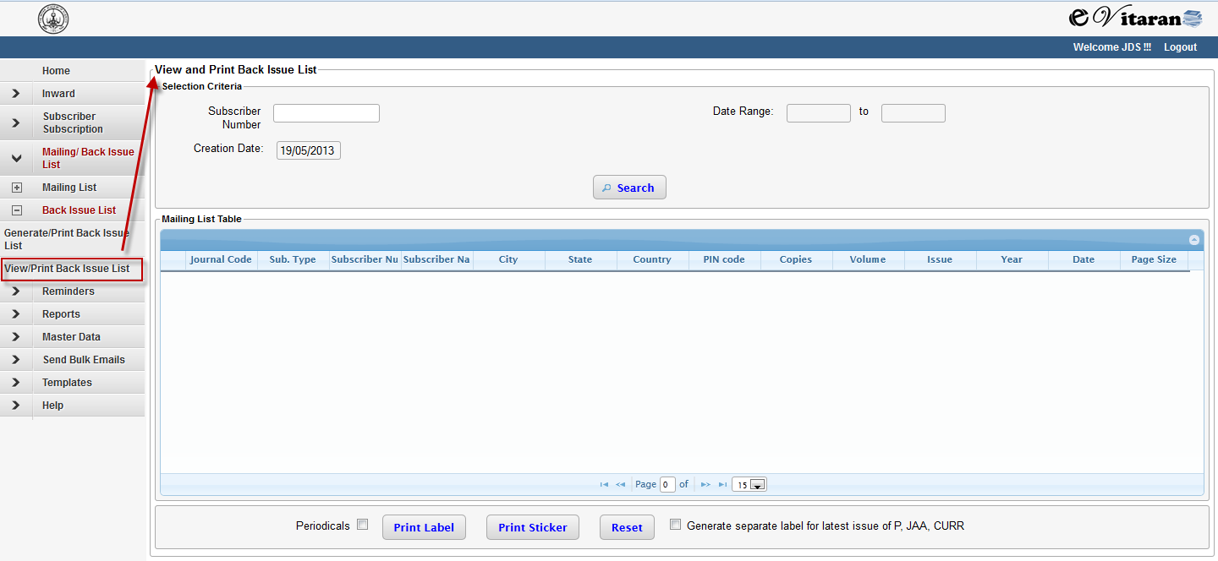

* Enter Subscriber Number or Date Range for which back issue list is to be reprinted.
* Press button ‘Search’ to load the back issue list.

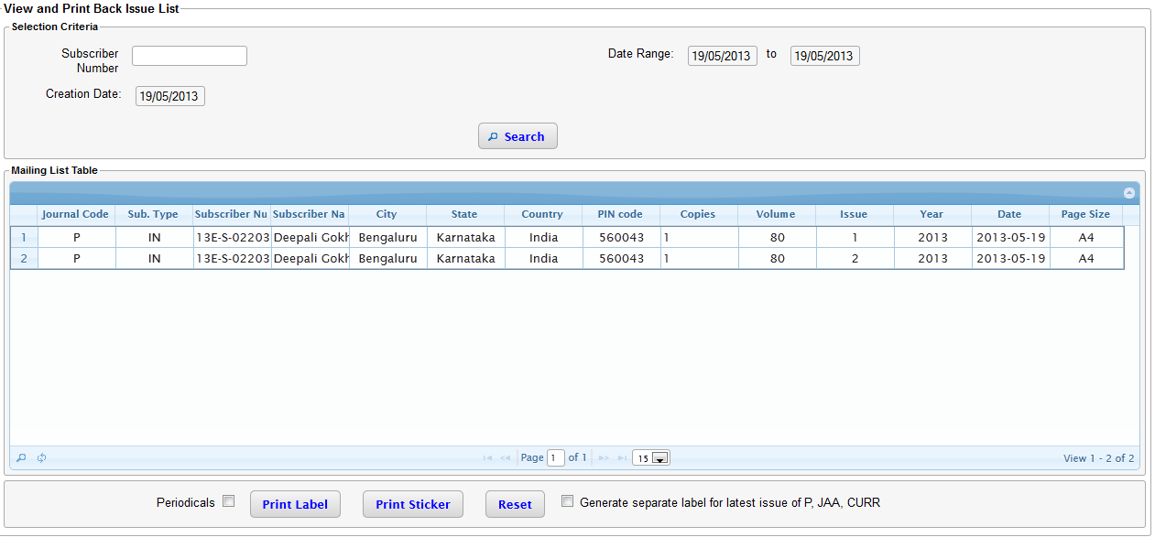

* Use ‘Print Label’ and ‘Print Sticker’ button to print the back issue.
* Back issue will be printed in the form of PDF.
* The journals will be grouped to form only one or two labels based on page size for a back issues.



* Use checkbox ‘Generate separate label for latest issue of P, JAA, CURR’ for generating separate label for Pramana, Journal of Astronomy and Astrophysics and Current Science.

# Reminders

The purpose of reminders is to remind the defaulter subscribers about the pending payment for ongoing subscription cycle. The reminders are of three types

* Type 1 Reminder – Gentle Reminder: This reminder type intimates the subscriber about the pending payment and requesting them to make payment.
* Type 2 Reminder – Strong Reminder: This reminder type is to re-remind with a bit stronger words to make the pending payment.
* Type 3 Reminder – Harsh Reminder: This reminder type goes as warning for subscriber that if you don’t make payment, subscription will be stopped.

Following section covers the details about the sending the resending of reminders.

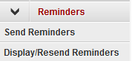

## Send Reminders

* Use menu option send Reminders to open ‘Send Reminder ‘ page.

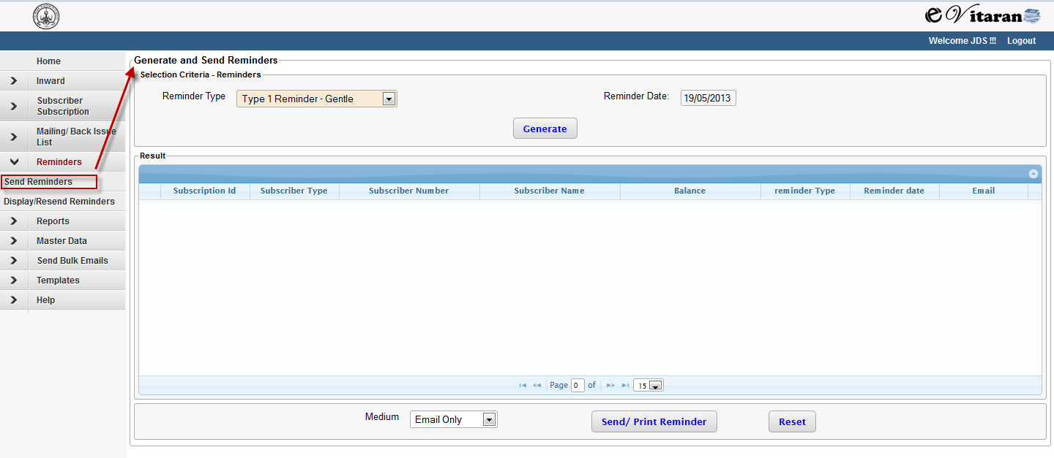

* Here select from the dropdown the type of reminder to be sent.

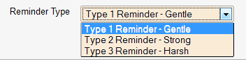

* After selecting the type of reminder click on ‘Generate’ to generate the reminders.
* On generating reminder s will be generated but will not be sent to the recipients.

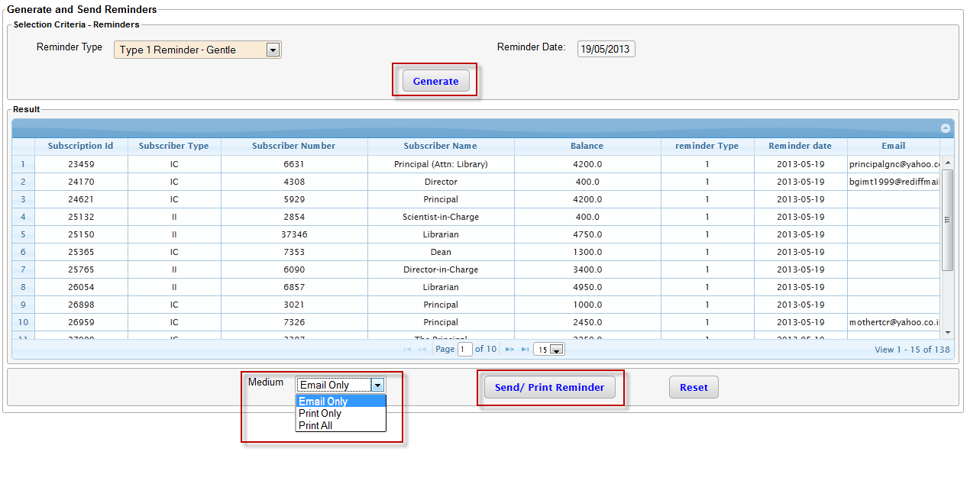

* Select the option of medium from medium drop down. In case of ‘Email Only’, reminders will be send to user with email via mail . In case of ‘Print Only’, reminders will be send to user with no email id via print. In case of ‘Print All’, reminders will be send to all users via print medium.
* The pdf content will be following format.

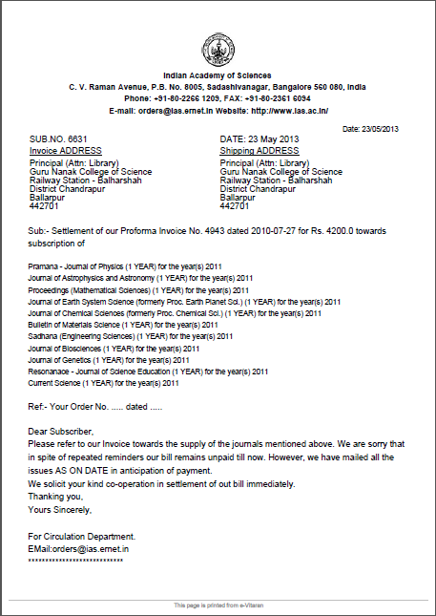

* The content will vary based on type of reminders

## Display and Resend Reminders

* Use menu option Display/Resend Reminders to open ‘Display and Send Reminder ‘ page.

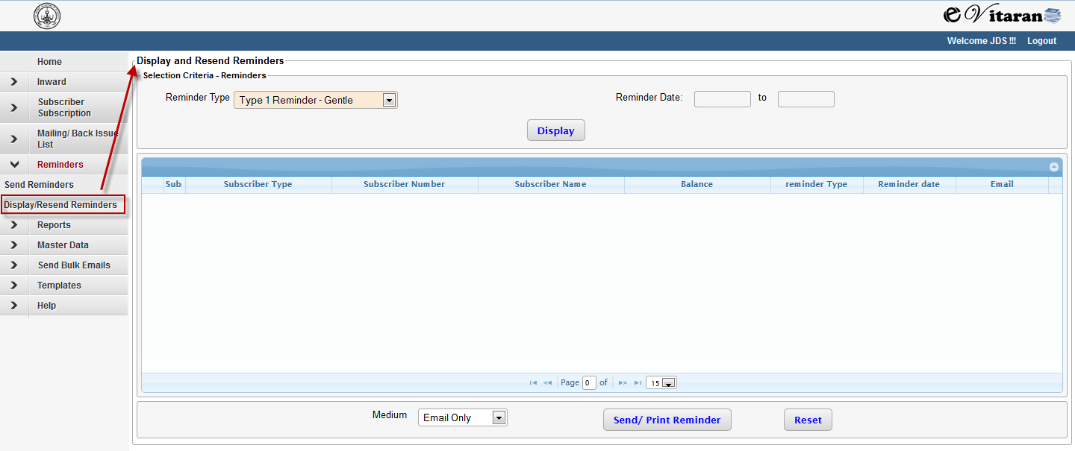

* The purpose of this is to reprint or send emails to subscribers, if these are not sent earlier while generating the reminder list.
* Here select from the dropdown the type of reminder to be sent and the date range in which the reminders were generated.



* After selecting the type of reminder click on ‘Display’ to load the generated reminders.

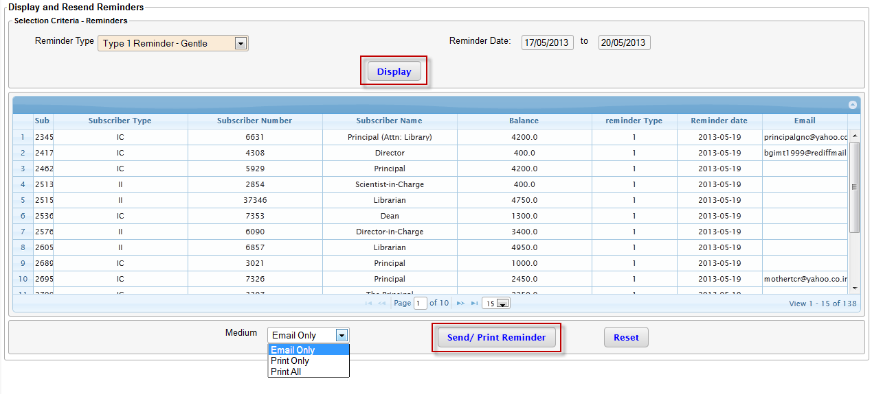

* Select the option of medium from medium drop down. In case of ‘Email Only’, reminders will be send to user with email via mail . In case of ‘Print Only’, reminders will be send to user with no email id via print. In case of ‘Print All’, reminders will be send to all users via print medium.
* The pdf content will be following format.



* The content will vary based on type of reminders

# Process Flow

## New Subscription

## Create Subscriber

The create subscriber screen is displayed when a new subscriber is registered in the system and the inward type is selected as “New subscription” or “Request for Invoice” and the subscriber id is left blank. All fields on this screen which are also present in the inward are populated with data that was entered in the inward. For e.g. City, State, Country, Email. The subscriber number field is read only and need not be filled by the user; a unique system generated id is used as subscriber number.

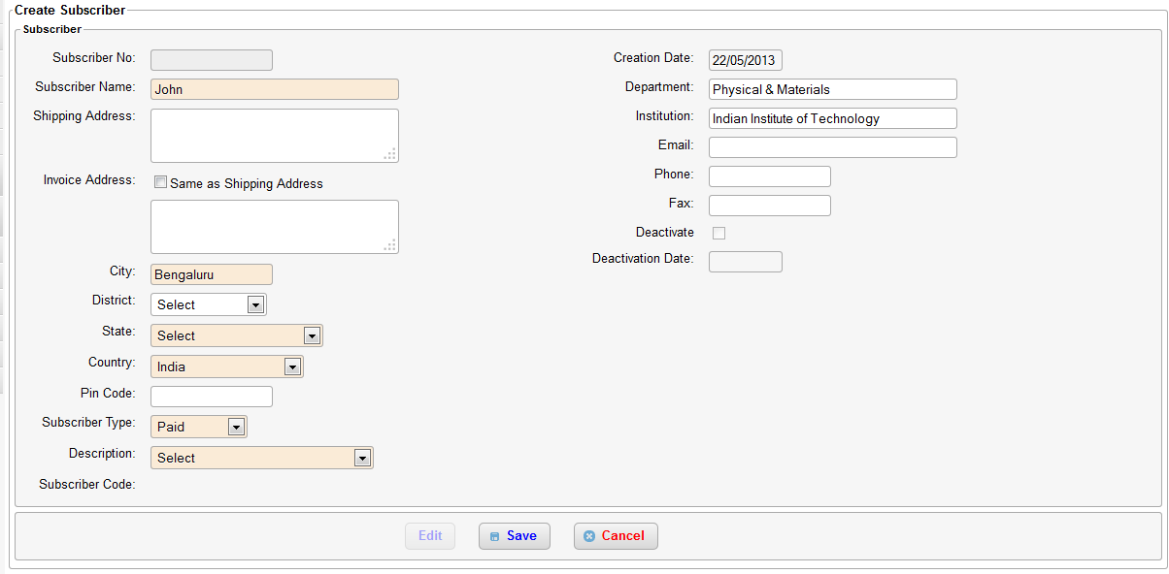

## Renew Subscription

### Create subscription

A Subscription can be created only by processing an inward of type Renew subscription/New subscription. To add a subscription follow the below steps.

* Create an inward with purpose Renew subscription, New subscription or Request for Invoice
* Navigate to Inward->Pending Inwards from the left menu
* Select the inward that for which a subscription needs to be created and click “Next”.
* If a subscriber is already selected (though for new subscription the subscriber should not exist) the create subscription will be directly displayed, else the create subscriber screen is displayed. Refer to Create subscriber section for further details.

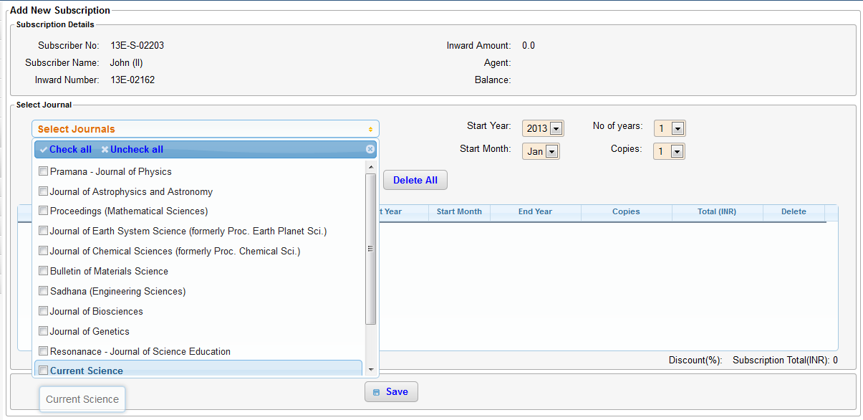

* From the “Select Journals” drop down select the journals the subscriber wishes to subscribe. Multiple journals can be selected at the same time by selecting the check box next to the journal name
* Select the start year, start month, number of years and copies
* Click on “Add”.
* If the subscriber has requested for multiple journals each having different number of copies or different start year then each such journal should be added individually
* Any discounts that are applicable for the subscriber are displayed at the bottom of the table
* The total subscription value (sum of all journal prices) is displayed at the bottom
* The balance and any amount already paid, agent name is displayed on top right side of the page
* Click on “Save” to create the subscription. If the balance is not zero then an invoice is created and displayed on saving. The invoice can be printed or emailed immediately. The invoice is also present under the invoices tab. To know how to navigate to invoice tab refer to section view subscriber details
* In case of the subscription already available for the period, warning message will be shown. If the user press ‘continue’ then the subscription with same period for the subscriber will be saved. If the user press cancel then it will not save the subscription.

## Address Change

Address change workflow starts with creation of an inward. The “purpose” of the inward is set to “Address Change”. The subscriber whose address has to be changed is selected using the “Search Subscriber” functionality and the inward is saved on clicking of “Save” button.

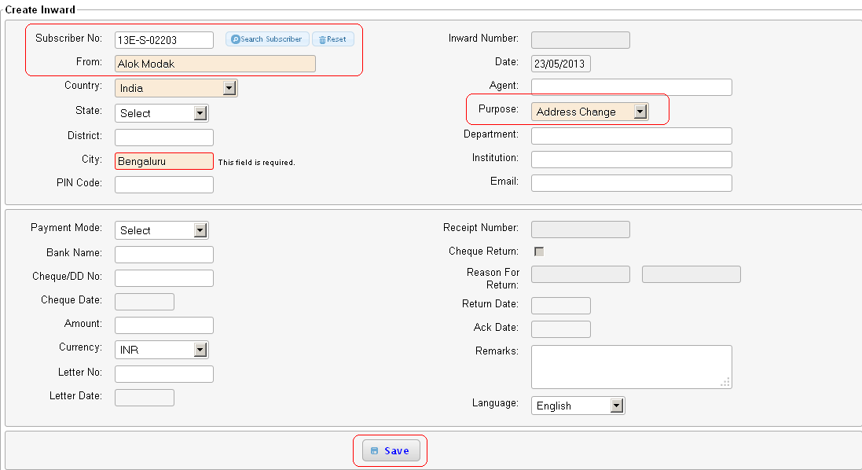

Next step is to select the correct from the “Pending Inwards” screen. The purpose will be shown as “Address Change” in the purpose column.

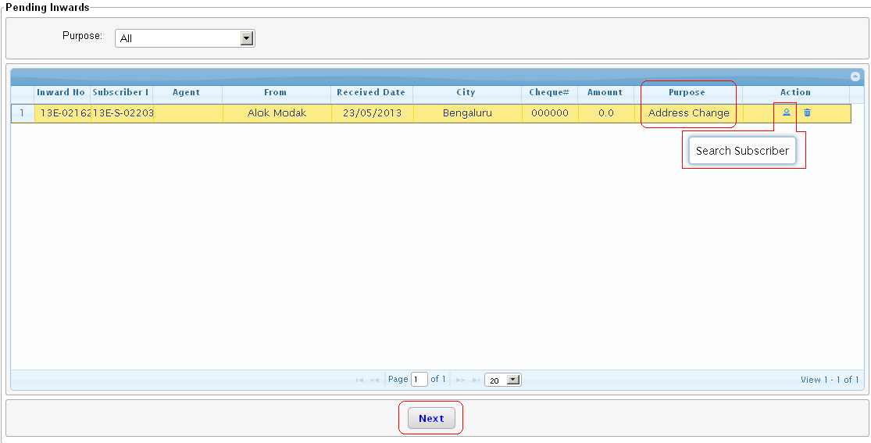

Clicking on the “Next” button will take you to the user to the “Edit Subscriber” screen. The information about the subscriber can be edited here and clicking on the “Save” button will save the new information.

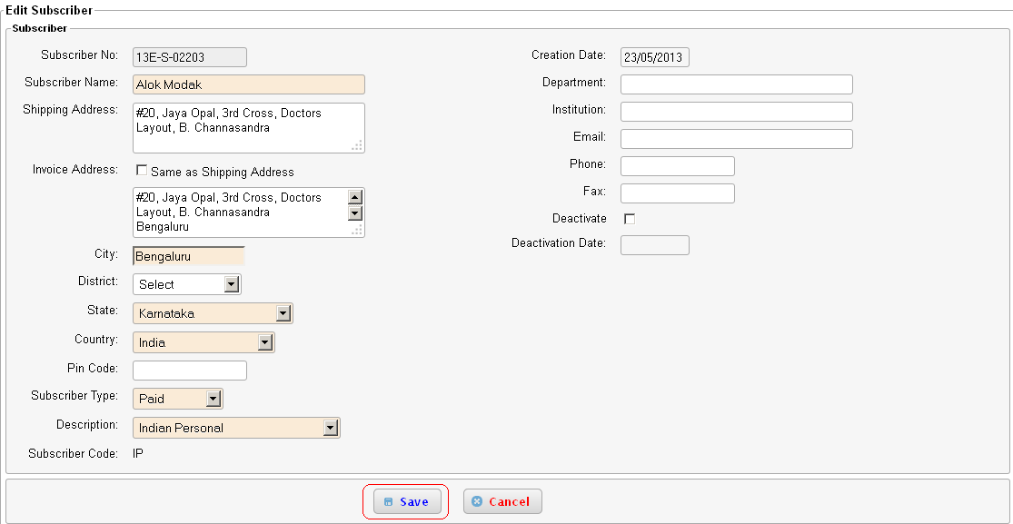

## Request for Invoice

The request for invoice workflow starts with creation of the inward, the purpose of the inward is set to “Request for Invoice” as shown in the figure below. The fields marked in “RED” are mandatory and once they are selected, the user should click on the “Save” button.

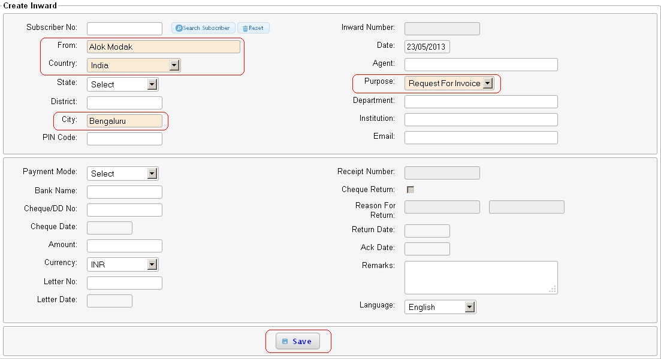

If the request for invoice has been sent by an existing subscriber, then the subscriber can be searched using the “Search Subscriber” button.

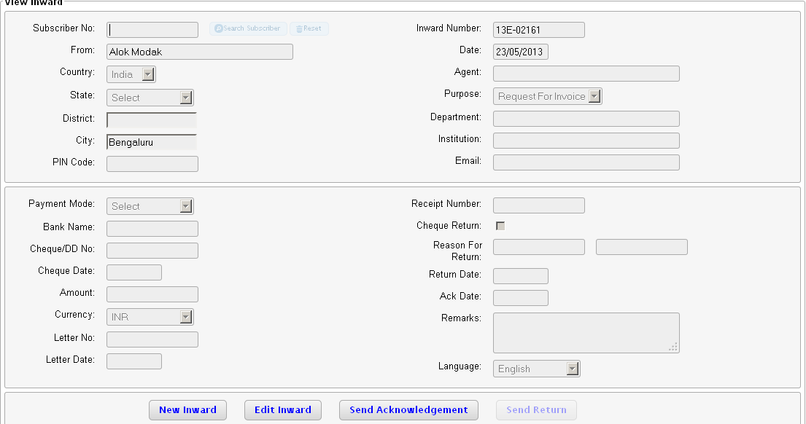

Once the inward is saved an acknowledgement can be sent to the user.

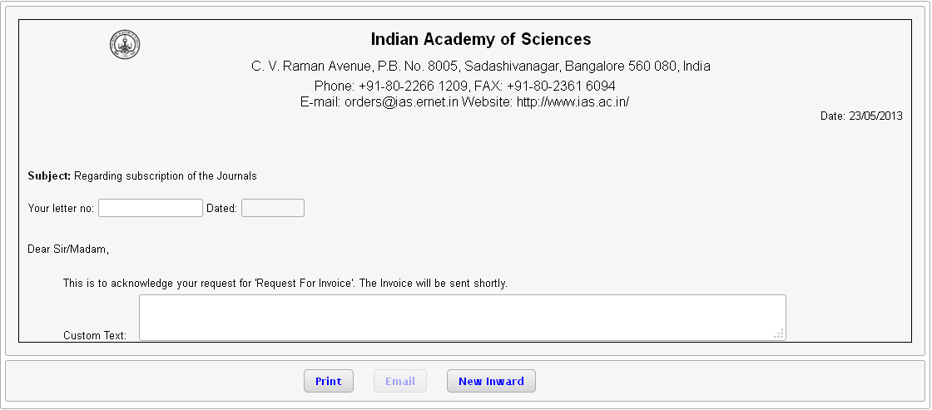

If emailID is present in the inward, then the “Email” button will be enabled and an acknowledgement of the request for invoice can be sent to the subscriber. The acknowledgement can also be printed using the “Print” button. Pressing of the “Print” button the acknowledgement will open in a new browser window. The output is in pdf (Portable Document Format).

Note: There is facility to enter custom text in the acknowledgement if additional information has to be communicated to the subscriber.



The inward created now needs to be processed. The list of inwards pending to be processed can be found in the “Pending Inwards” screen. The purpose will be marked as “Request for invoice”. Select the correct inward to be processed and then press on “Next”.

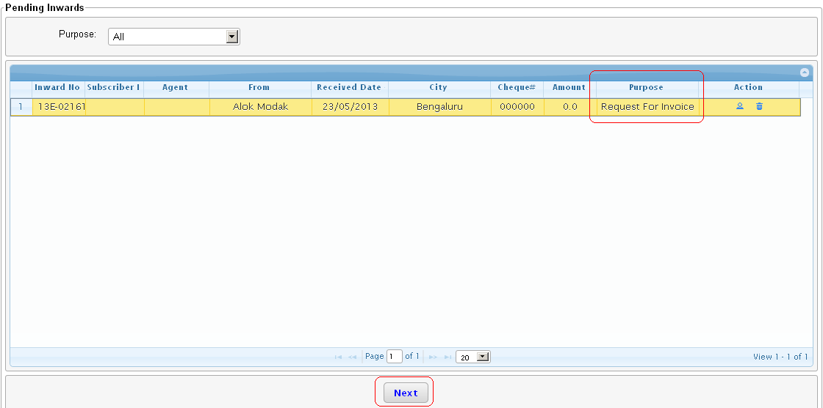

Note: Request for invoice workflow will lead to creation of a new subscriber if the subscriber is not present. If the subscriber is present then it will directly lead to creation of the subscription information.

Once the mandatory information (marked in RED) is entered the subscriber details should be saved by clicking on the “SAVE” button.

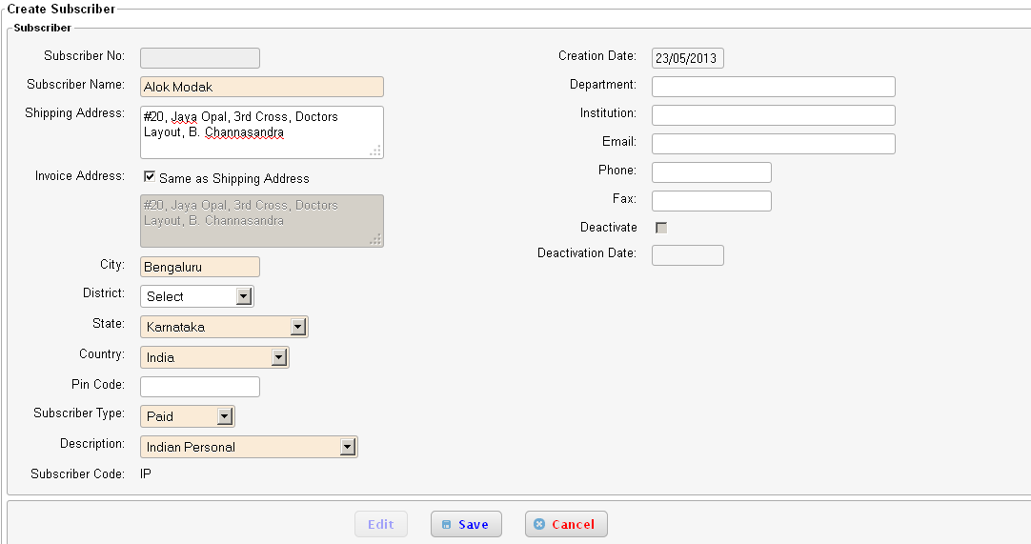

On saving the subscriber details, it will lead the user to the subscription creation page. The user can select the journals as requested by the subscriber and the subscription should be saved by clicking on the “SAVE” button.

Note: This screen also shows the balance information.

Note: If a subscription is incorrectly entered, then the subscription can be deleted by clicking on the “-“ sign in the “Delete” column.

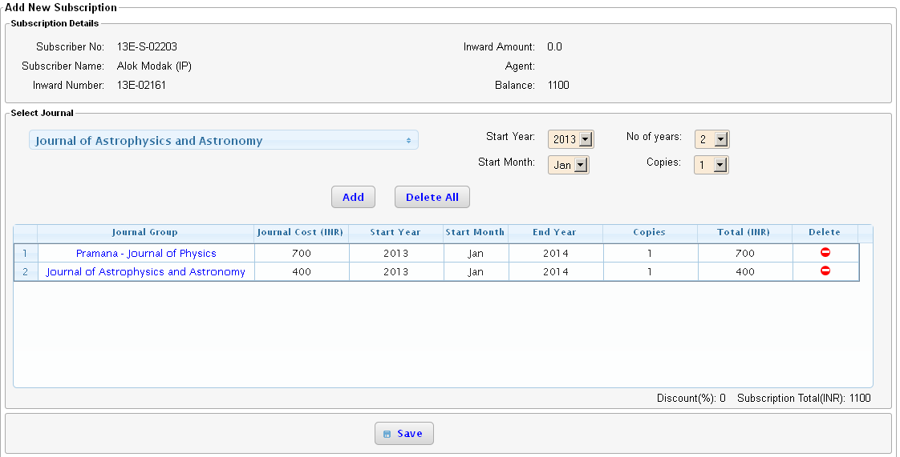

Clicking the “SAVE” button will lead the user to the invoice page. The list of journals selected and the balance information is displayed on the screen.

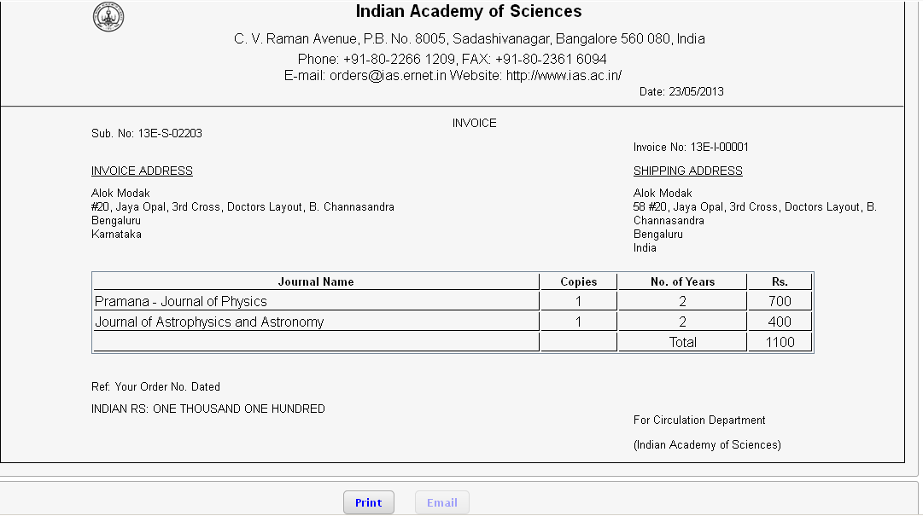

Clicking on “Print” will open the invoice in a new screen and the document will be displayed in a pdf (Portable document format). If emailID is provided while creating the subscriber, then the “Email” button will be enabled and the invoice can be emailed to the subscriber. The invoice in form of a pdf is sent to the subscriber.

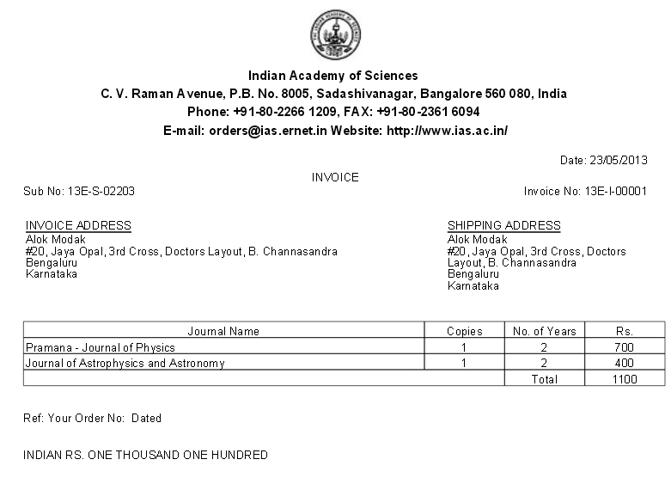

## Payment

If a subscription is created with a non-zero balance an invoice is generated automatically by the system. To view the list of invoices for a subscriber refer view subscriber details.

The subscriber on receiving the invoice may wish to send a payment via cheque/demand draft/bank transfer or money order. To add a payment to an existing invoice follow these steps:

* Create an inward purpose “Payment” and fill in all the mandatory fields that are marked in red. Payment information like cheque number, date and amount are mandatory fields for payment inward. Enter the subscriber number is known. Save the inward.

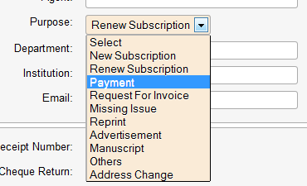

* Navigate to pending inwards and select this inward, press “Next”. The payment screen as shown below will be displayed. If the subscriber number fields is blank you will be prompted to select an existing subscriber.

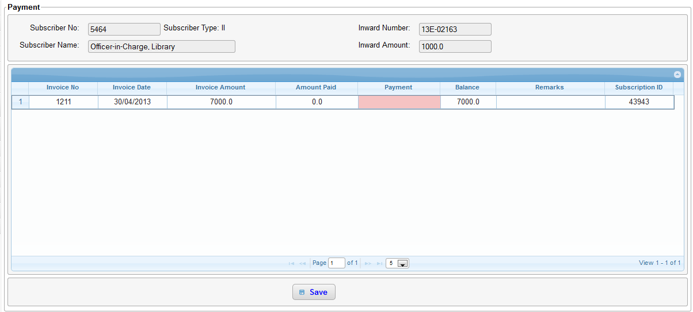

* Click on the red text box under the payment column. Now enter the amount you wish to pay towards the invoice. Now press enter again. The amount entered cannot exceed the inward amount as shown on top of the page. The user has an option to split the inward amount among multiple invoices and again the sum of all these payments cannot exceed the inward amount.
* No payments can be made against invoices which has a zero balance.
* If the entire balance amount is paid the payment is marked as “Full Payment” else “Partial Payment”
* All payments are considered in INR.
* Click on “Save” when all payments are added. A confirmation message as shown below is displayed.

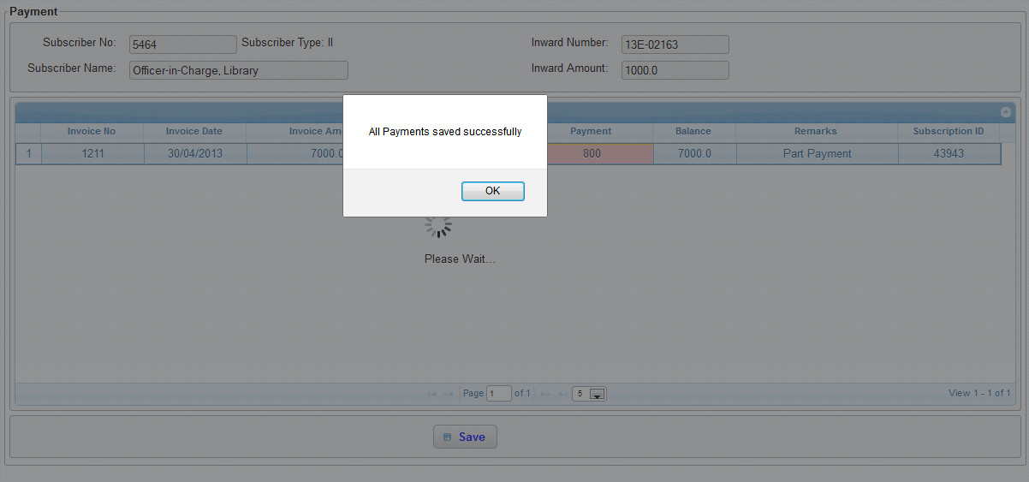

* To view the list of invoices and payments made (shown below) for a subscriber refer view subscriber details.

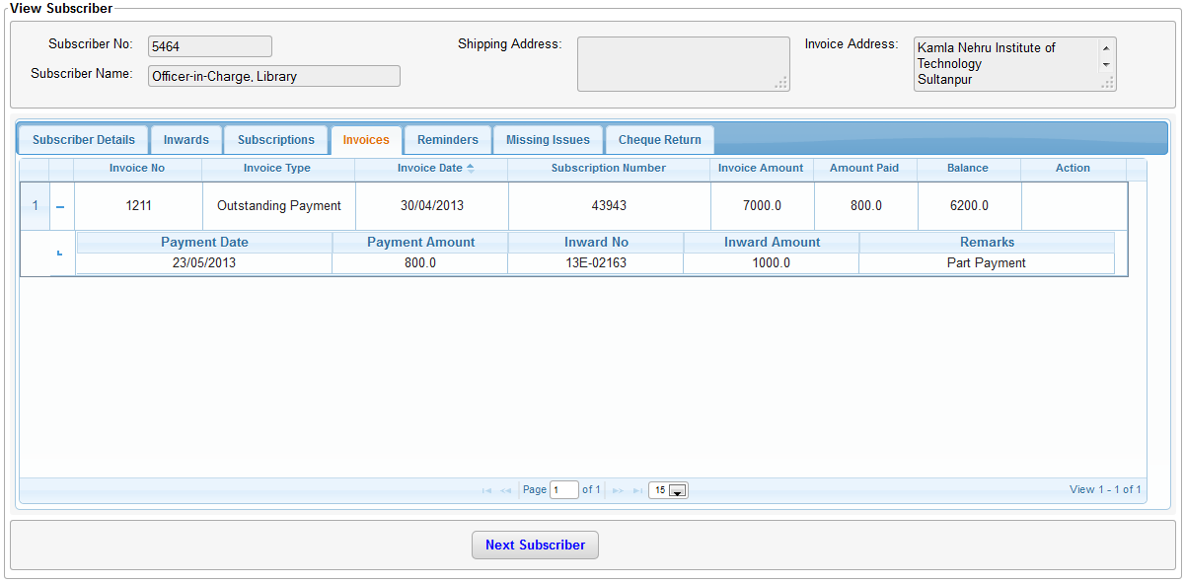

## Missing Issue

Missing Issue is about receiving claims from subscribers about not receiving some issues.

* For creating missing issues, first Inward of type missing issue should be created.

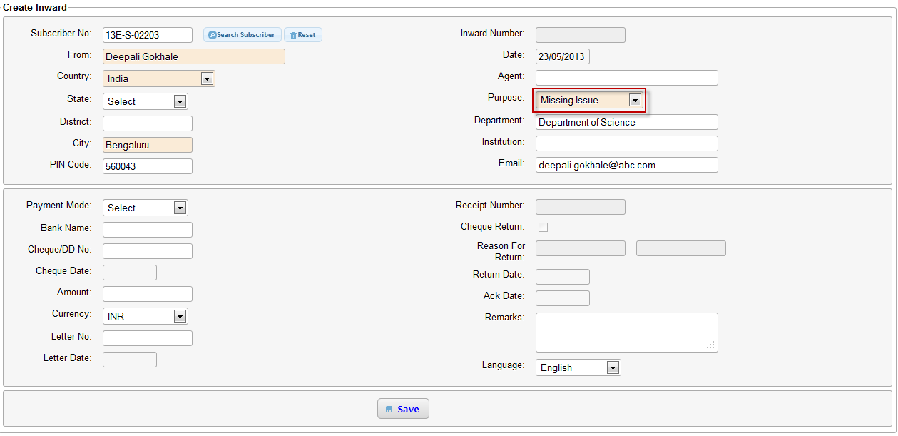

* Then navigate to pending inwards. There filter based on purpose as ‘Missing Issue’ for easy search.

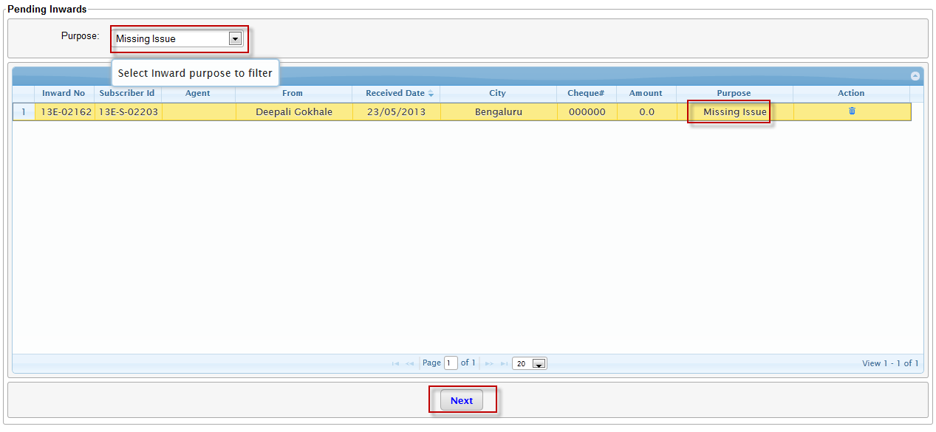

* Select the Inward to be processed and press ‘Next’.
* This will take you to ‘Missing Issue’ page.

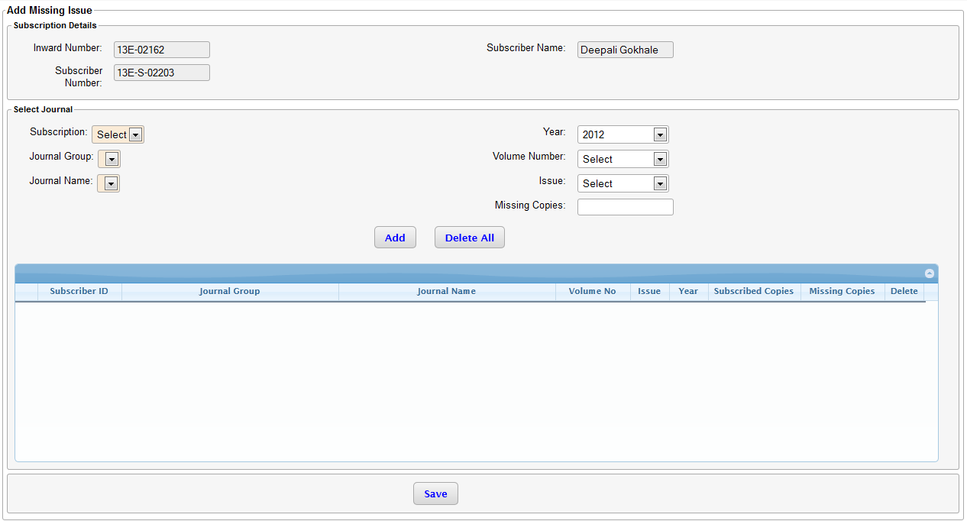

* Here select the Subscription, Journal Group, Journal Name, Year, Volume Number, Issue and number of missing copies and click on Add. This will add missing issue details to the table. Repeat this for the entire issue request for all the journals for this subscriber.
* The respective dropdown will load information for only the journals for which mailing list is already generated.
* Delete option is available to delete the incorrect entries.

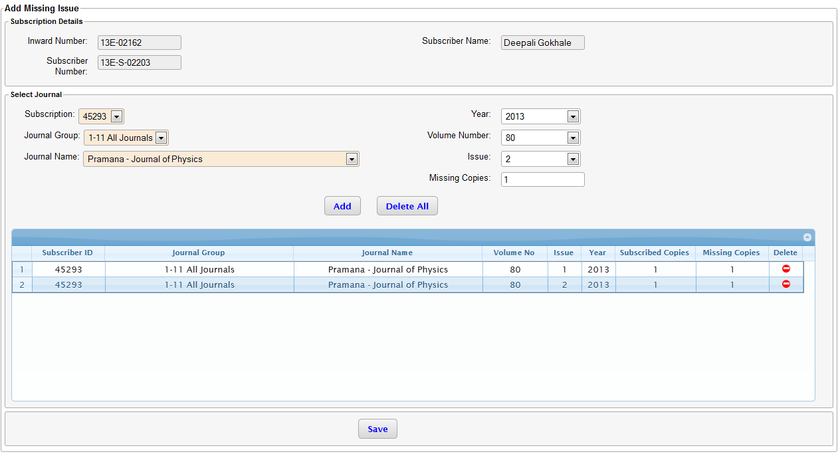

* Once all the issues are added press save.
* Success message will be displayed.

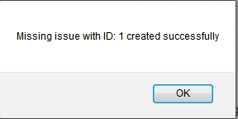

* This will navigate the user to the next screen, where action about the missing issue can be taken.

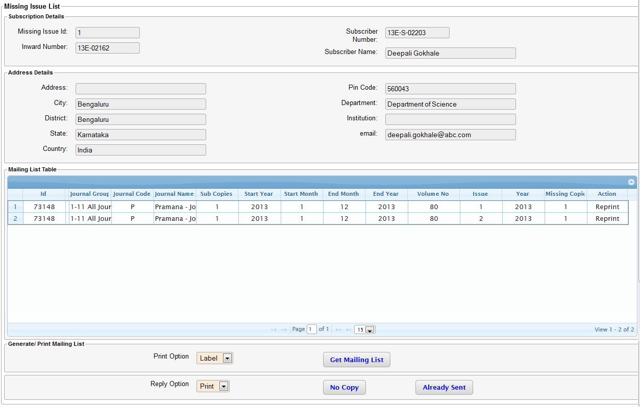

* If issue is not send to the subscriber then in the action column of mailing list table ‘Generate’ will come. Else the value there will be reprint.
* You can choose to generate sticker or label, in case issues need to be send to subscriber.
* In case of issue not required to be send to subscriber, subscriber can be informed by mail or print option about ‘No Copies’ or ‘already Sent’.

# Reports

Reports of various types can be generated from the eVitaran system. Broadly they are classified in 3 types as illustrated in the figure below and are available under the “Reports” menu.

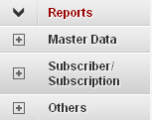

## Master Data

The reports under this section are of the following types:

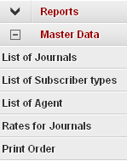

### List of Journals

This report can be used to provide the list of all journals that fall in a group. Use the drop down under the “Journal Group” and press the “Search button”.

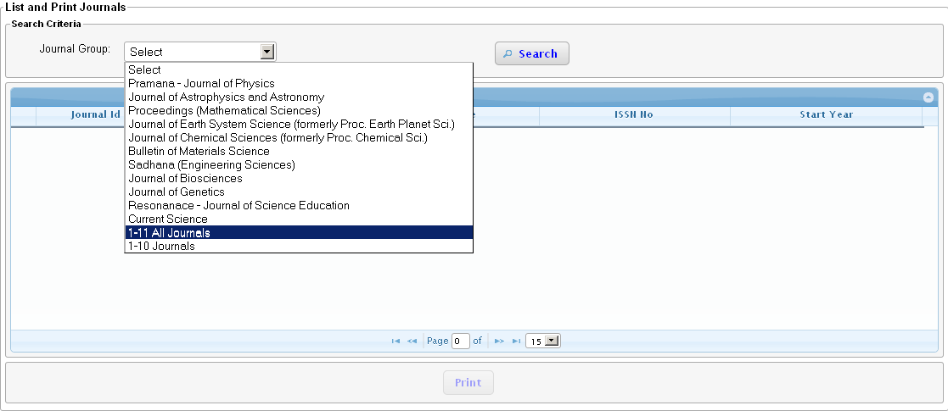

The list of journals falling within this group is displayed in the table below.

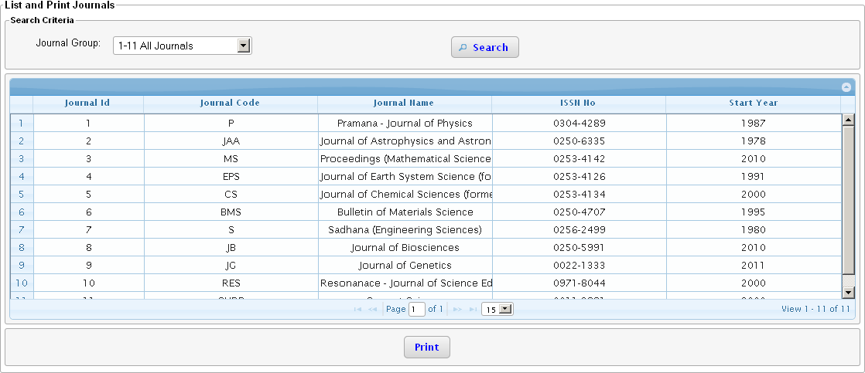

The data displayed in the table can be printed using the “Print” button.

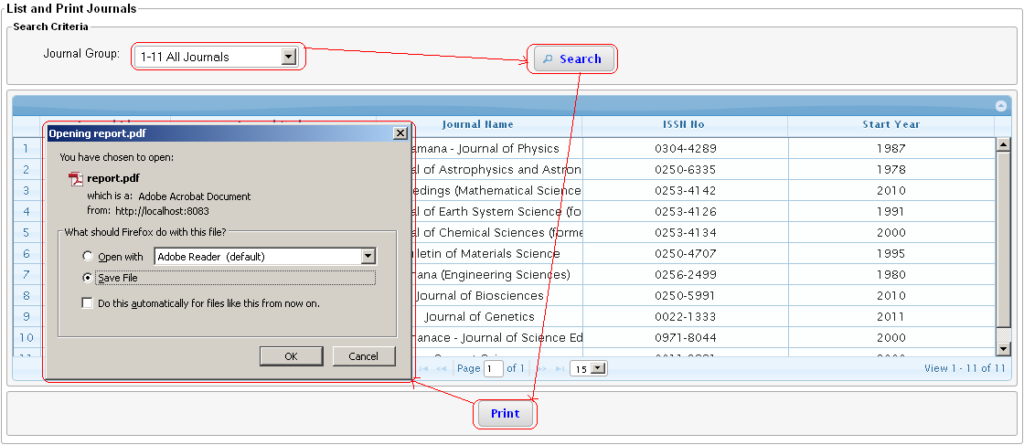

**Note: The output of the print option is generated in form a pdf (Portable Document Format). This is a feature common for all the reports.**

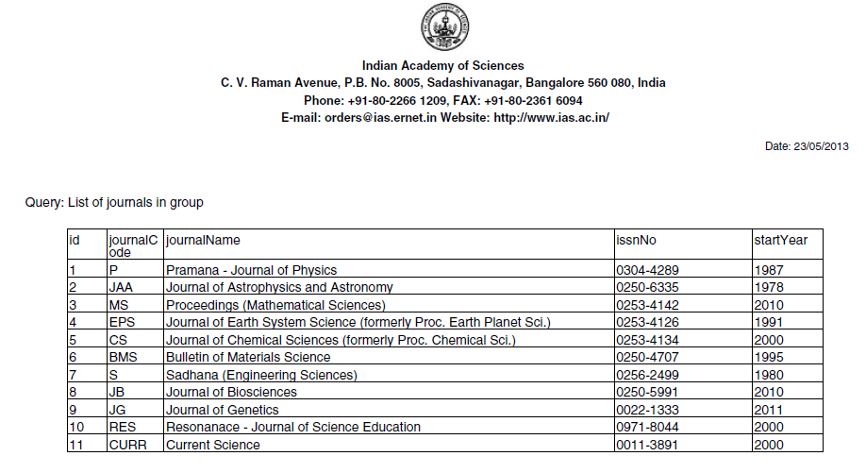

**Note: There are some common elements that can be found in all the reports i.e. the Header, date of report generation and the type of report.**

The journal groups are defined in the master data.

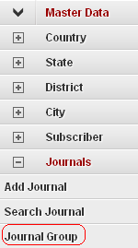

### List of Subscriber Types

The list of all the subscriber types can be found using this report. The figure below shows a way to generate the list of all the subscribers defined in the system by selecting the “All Subscriber Types”.

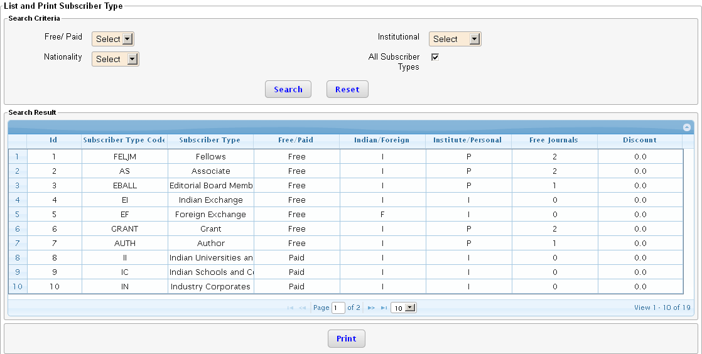

### List of agent

The list of agents can be searched by using the “Country”, ‘State” or “City” criterion. All the agents in the system can be searched by selecting the checkbox “All agents”.

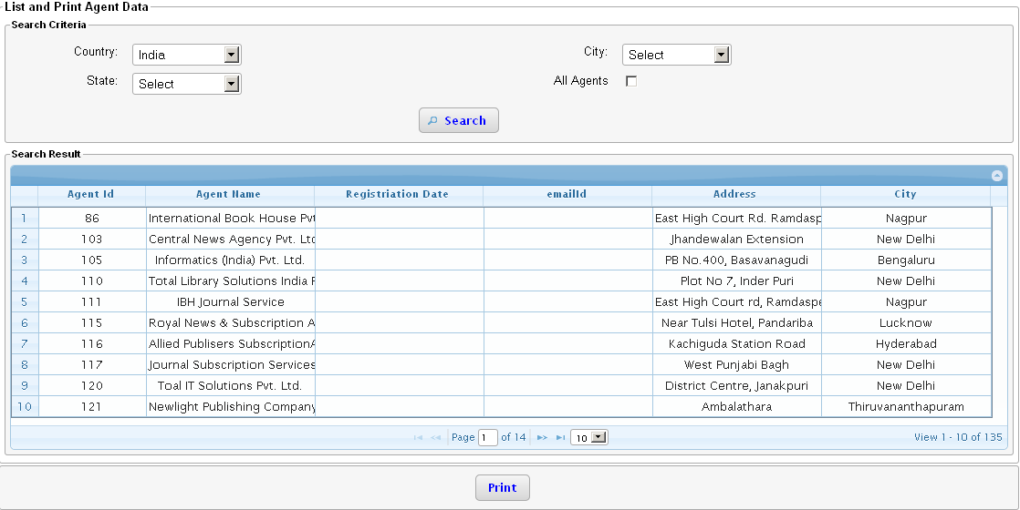

### Rates for Journals

The rates defined for a journal or a journal group for a particular year and subscriber type can be viewed using this screen.

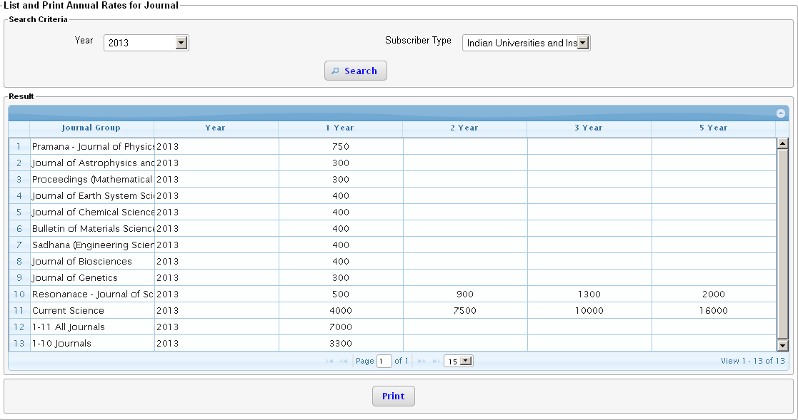

### Print Order

The print order defined for a year can be viewed using this screen. The first row indicates the issue number and the first column the journal name. If a cell in the table contains a “NA” means that the issue number is not defined for this journal for this year. Once the print order data is populated in the system using the “Master Data”, the number will be reflected in this screen as a consolidated figure for all the journals.

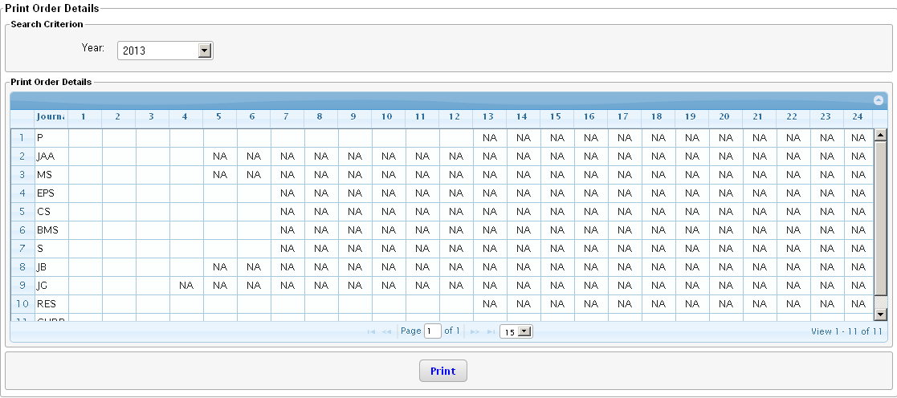

## Subscriber/ Subscription

The reports under this section are of the following types

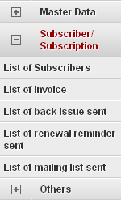

### List of Subscribers

The list of subscribers can be generated using various search criterions as shown in the figure below. The figure below shows an example of how the list of all subscribers residing in Bengaluru can be generated (by selecting the “City” as “Bengaluru” and clicking on the “Search” button).

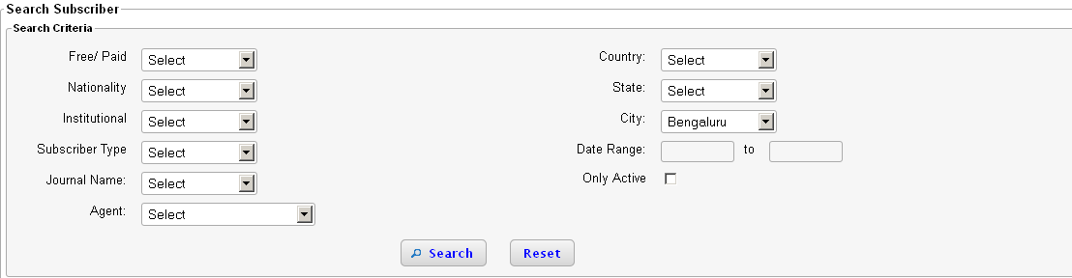

Labels and stickers can be generated for the list of subscribers generated using the search criterion above.

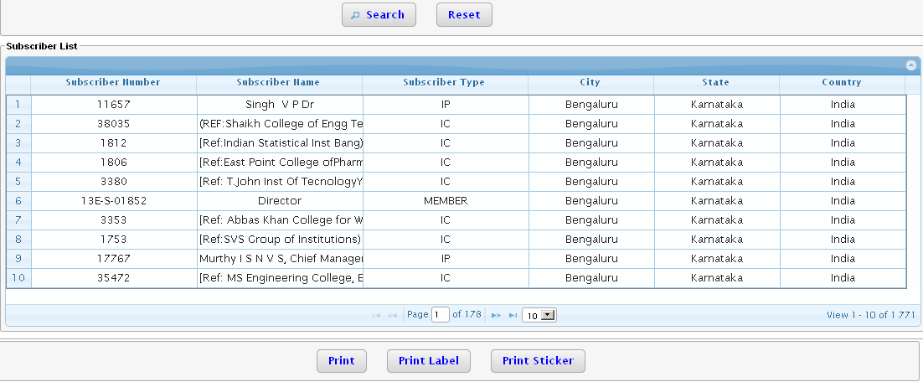

### List of invoice

A report of the various types of invoices sent generated from the system using this option.

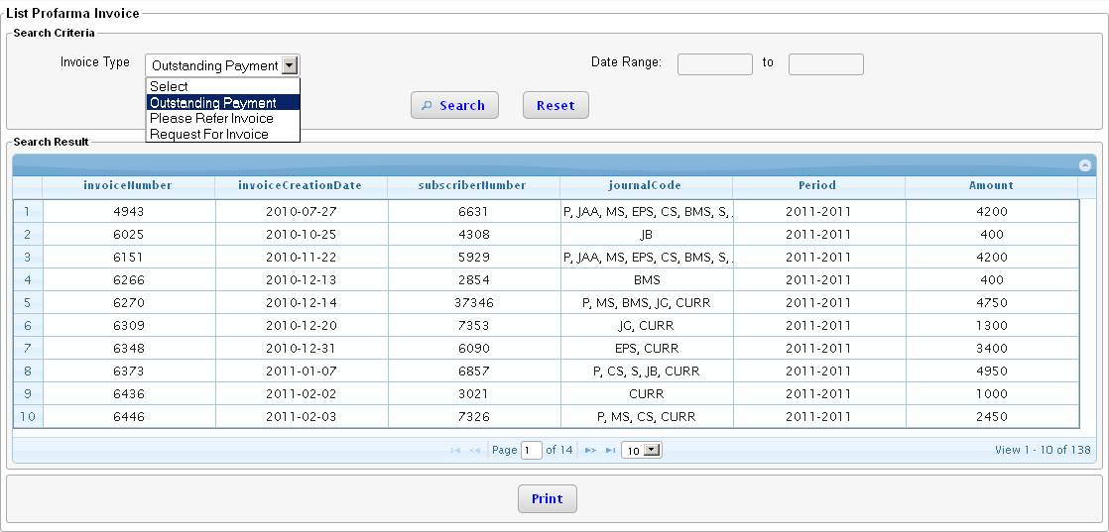

The sum total of the amount is show on the last page of the table.

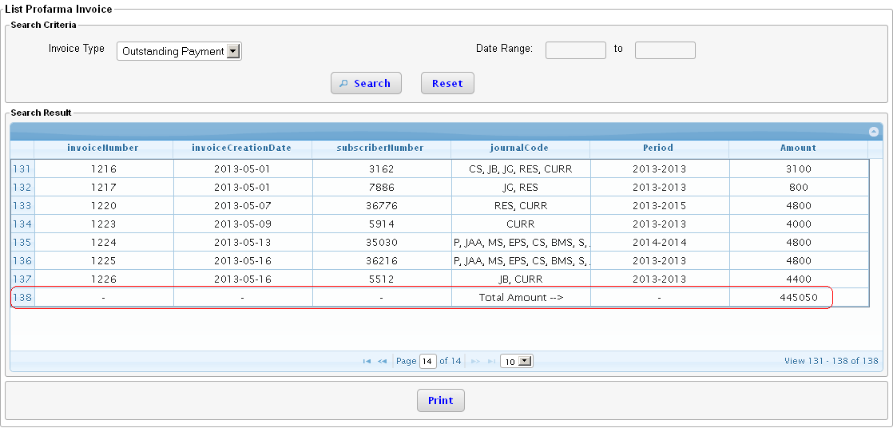

### List of back issue sent

This report can be used to via in a single view how many back issues have been sent.

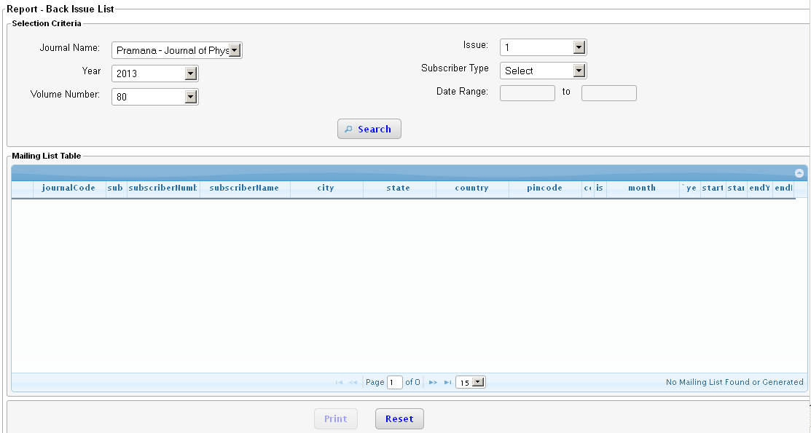

### List of renewal reminder sent

This report can be used to find out in a single view how many to whom reminders of various types have been sent.

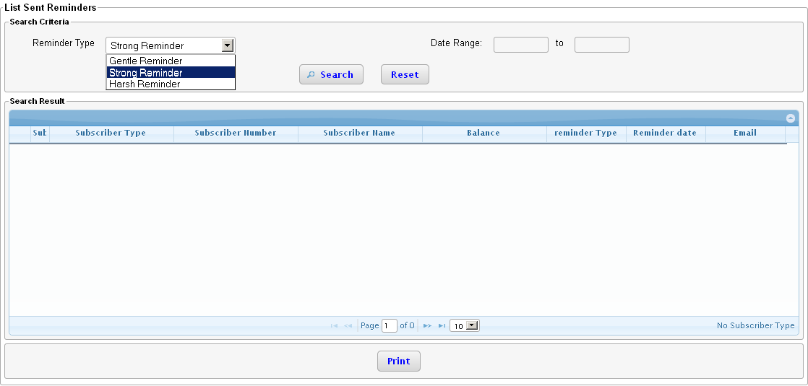

### List of mailing list sent

This report can be used to generate the list of all subscribers to whom a particular mailing list has been sent.

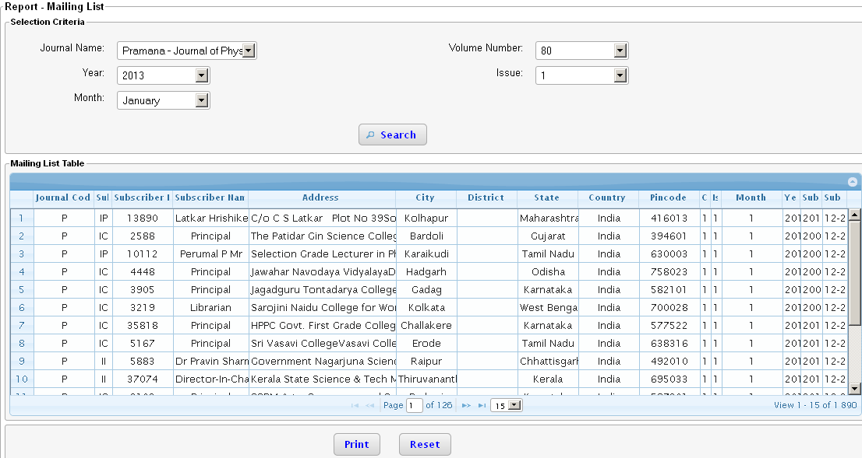

## Other Reports

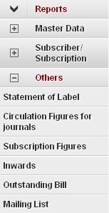

### Statement of Label

This report can be used to generate the subscriber count and no of copies shipped in a particular mailing list. This data is generated from the mailing list.

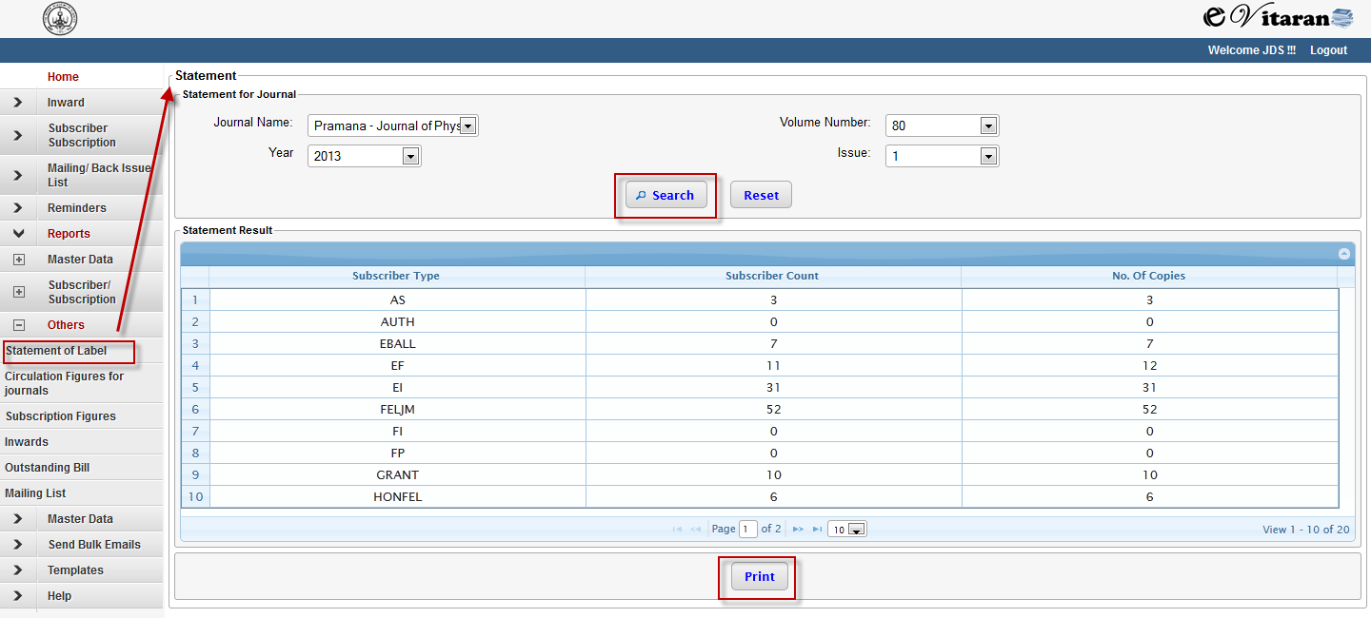

### Circulation Figures for Journals

This report can be used to view the number of copies that have been shipped in a particular mailing list. The subscriber type in this report is limited to only the following type of subscribers “Institutional India and abroad”, “Individual India and abroad”, Compensatory, Authors. This report also takes into account the print order and shows the balance copies. The result here are based on mailing list.

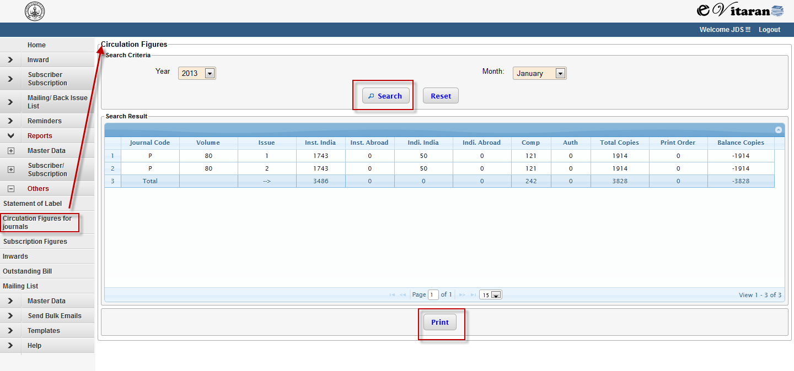

### Subscription Figures

The report can be used to view count and copies for different subscriber types for all the Journals. This is based on subscription data.

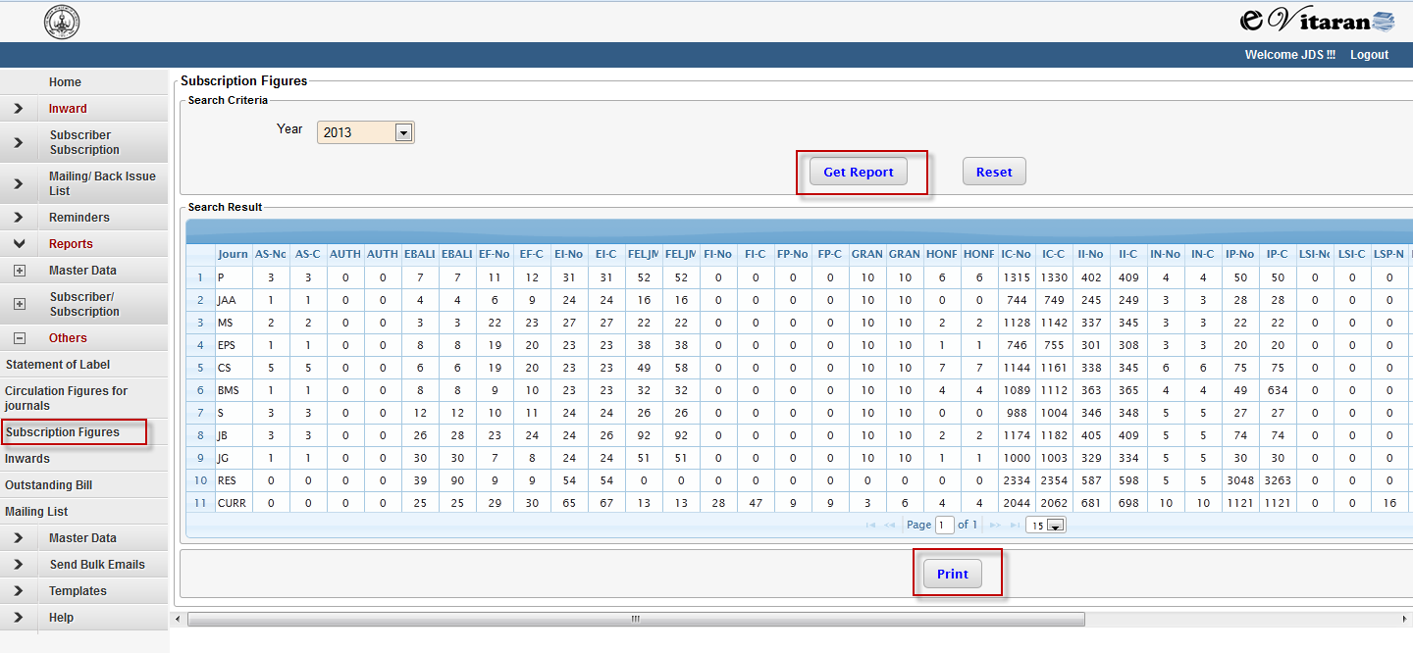

### Inwards

This report can be used to find any inward that has been registered in the system. There are various search criterion provided in the user interface.

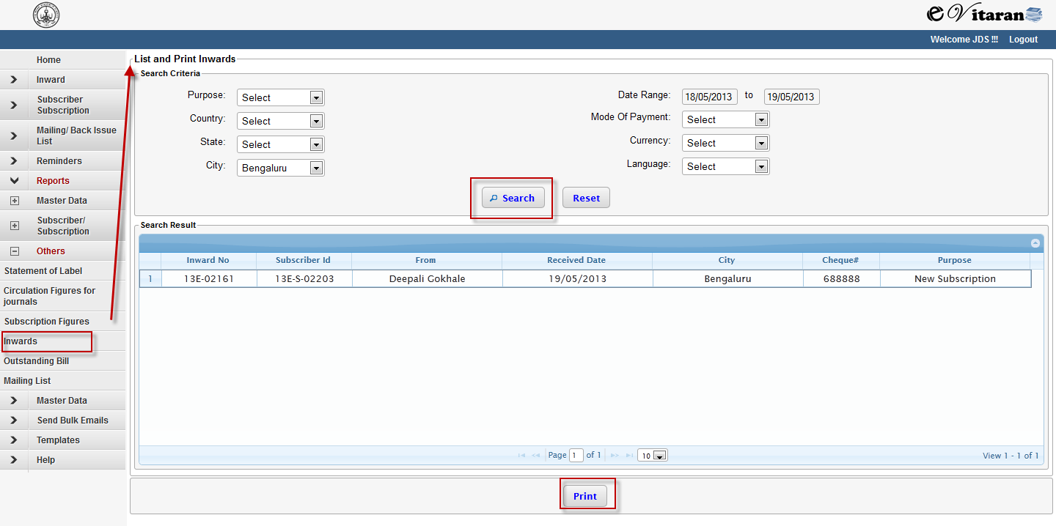

### Outstanding Bill

This report can be used to generate the list of all subscribers who have outstanding bill. Various search criterions are available in this report. The sum total of the outstanding balance is shown in the table.

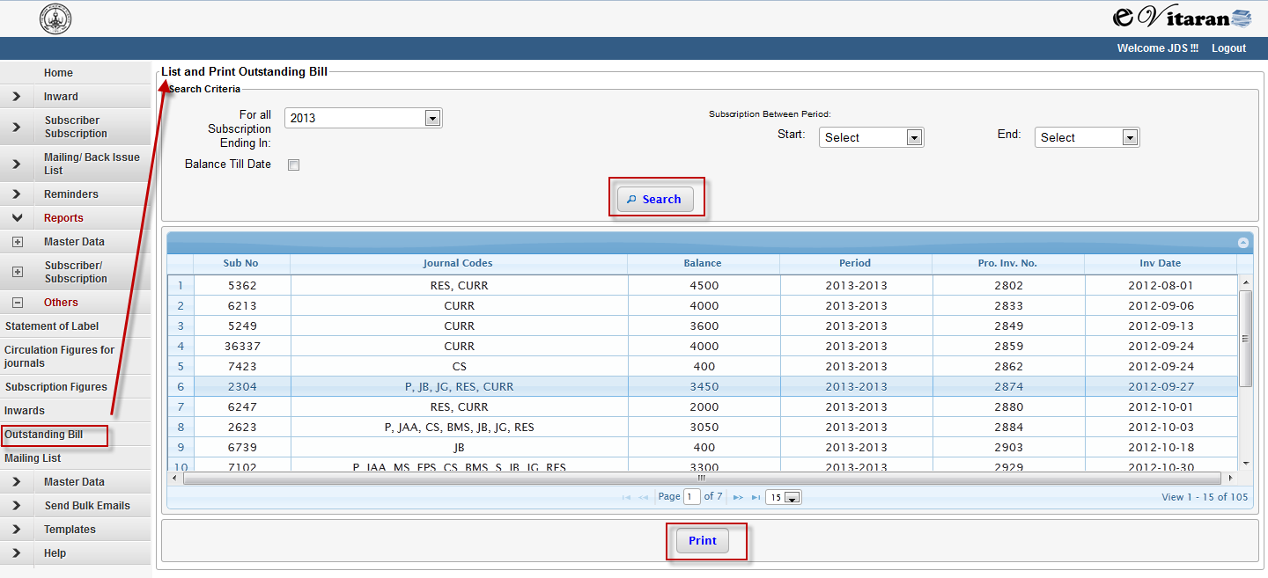

### Mailing List

This report can be used to find out the details on the mailing list generated in a particular year. This report also shows the date when the mailing list has been generated.

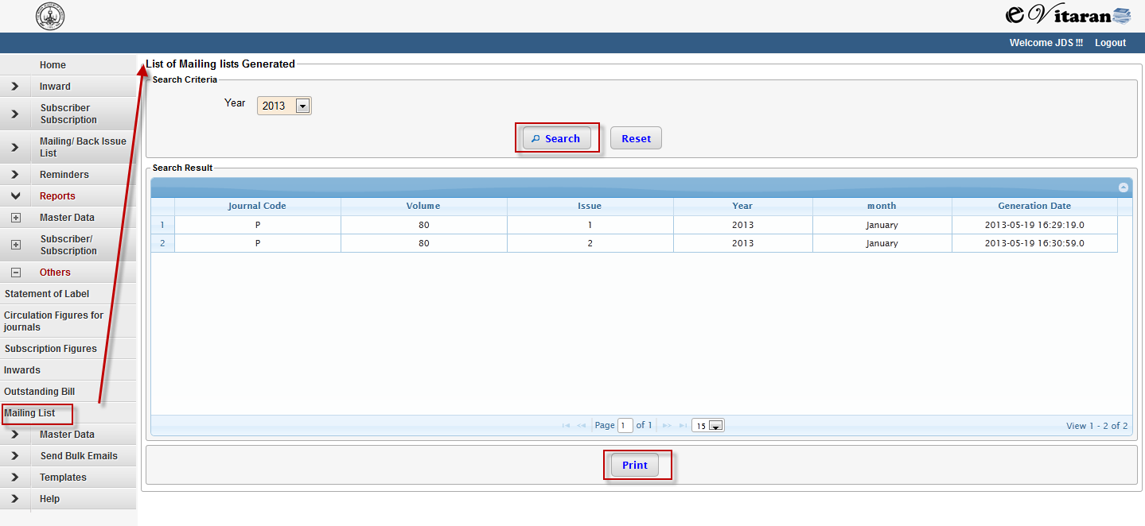

# Bulk email Sender

* Bulk email sender enables you to send a mail to different people.
* The mail id should be comma or space separated
* There is also a provision to get the email ids from database.
* Email ids can be retried for different categories of subscriber.

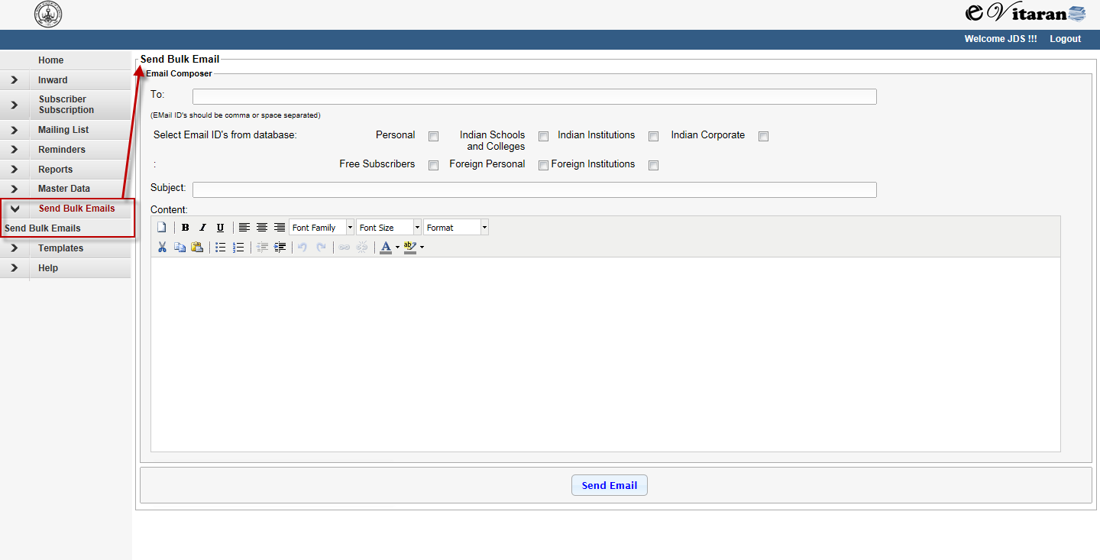

Steps to send bulk email:

1. Press menu item Send Bulk email.
2. Enter email id in ‘To’ field
3. In case of email id error message will be shown
4. Select the check boxes if the reminder is to be sent to all the subscribers with valid email id in the category. (You can select multiple check boxes at a time.)
5. Enter subject and content.
6. Several formatting options like copy, paste, cut, Bold, Italic, underline, different font type, font sizes, font color etc. are provided for content text.
7. Press the ‘Send Email’ button to send mail
8. Success or Failure messages will be displayed on completion of sending email, as per the status.

# Template

In this section you can find the agent excel upload template.

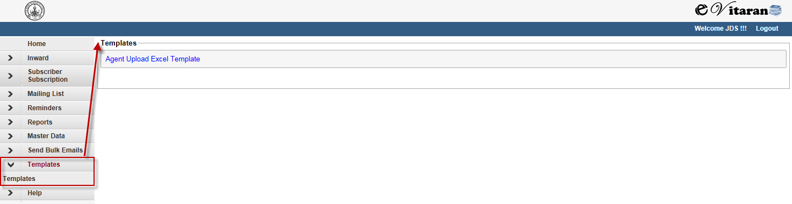

# Help

In this section you can find the Help Documentation for the eVitran Software.

